1. Create a new GitHub repository.

* Clone the repository to your local machine using SSH (generate an SSH key if needed, add the public key to your GitHub account).
* Create a new branch named after your username (e.g., Tutedude).
* Add your Flask project files to this branch.
* Commit the changes and merge the branch into the main branch.

Ans.

Step 1: Created a new repository on github named **‘tutedude_assignment4’**.

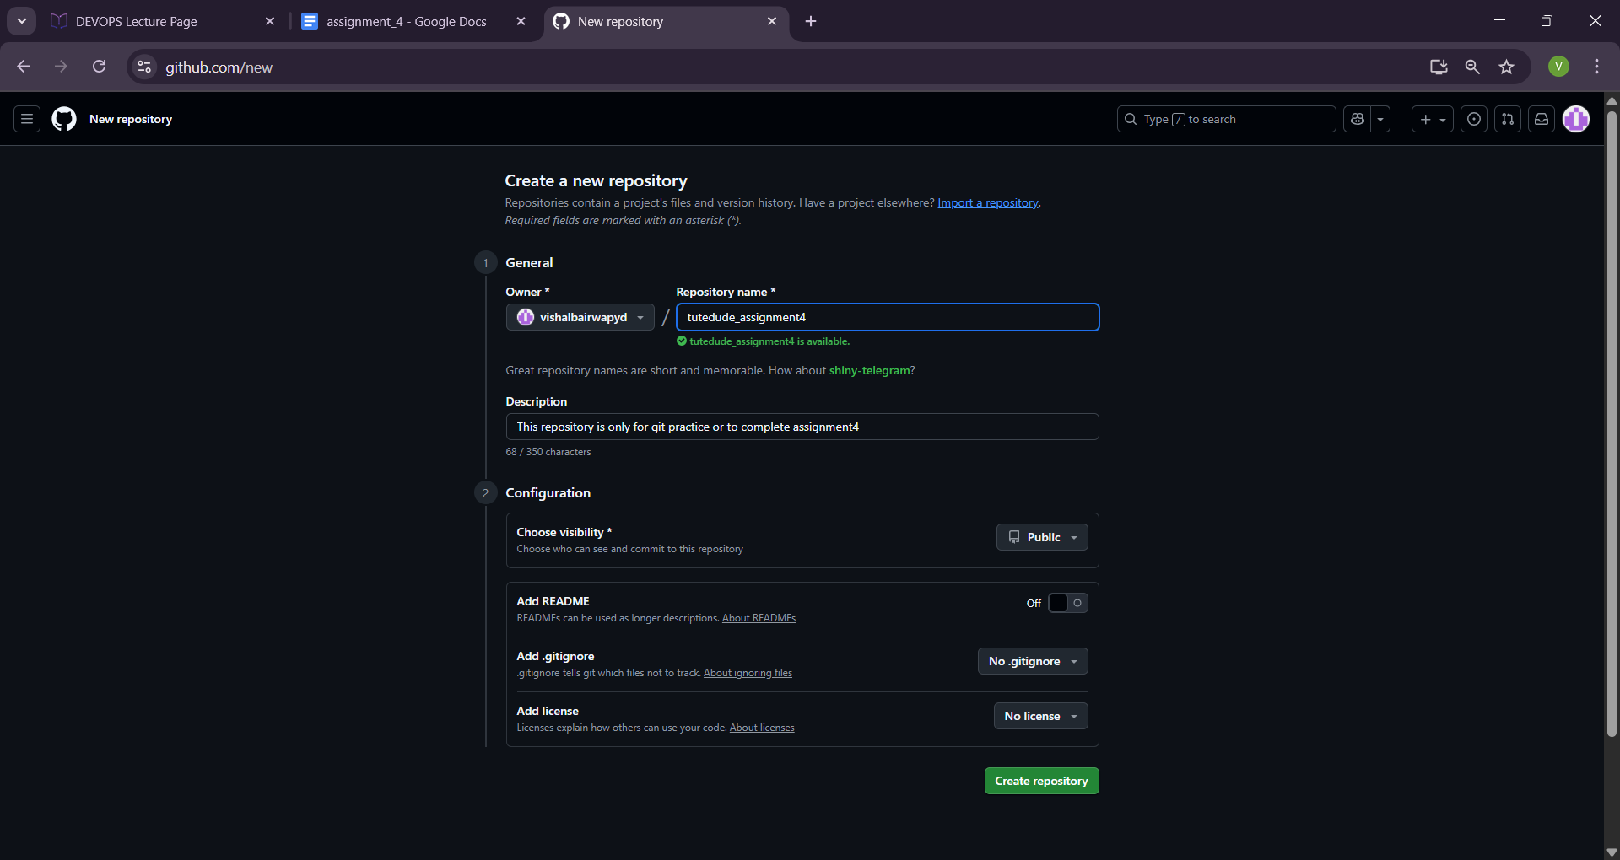

Step 2: Created a file on github named **“info.txt”** and committed it.

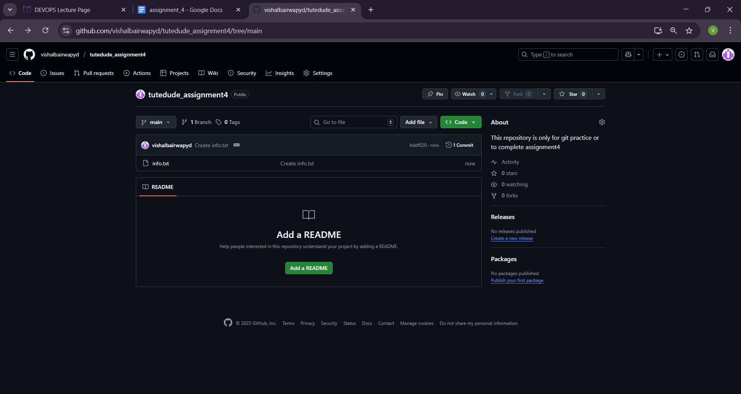

Step 3: Copy github repository link ***“https://github.com/vishalbairwapyd/tutedude_assignment4.git”*** for cloning to fetch in local.

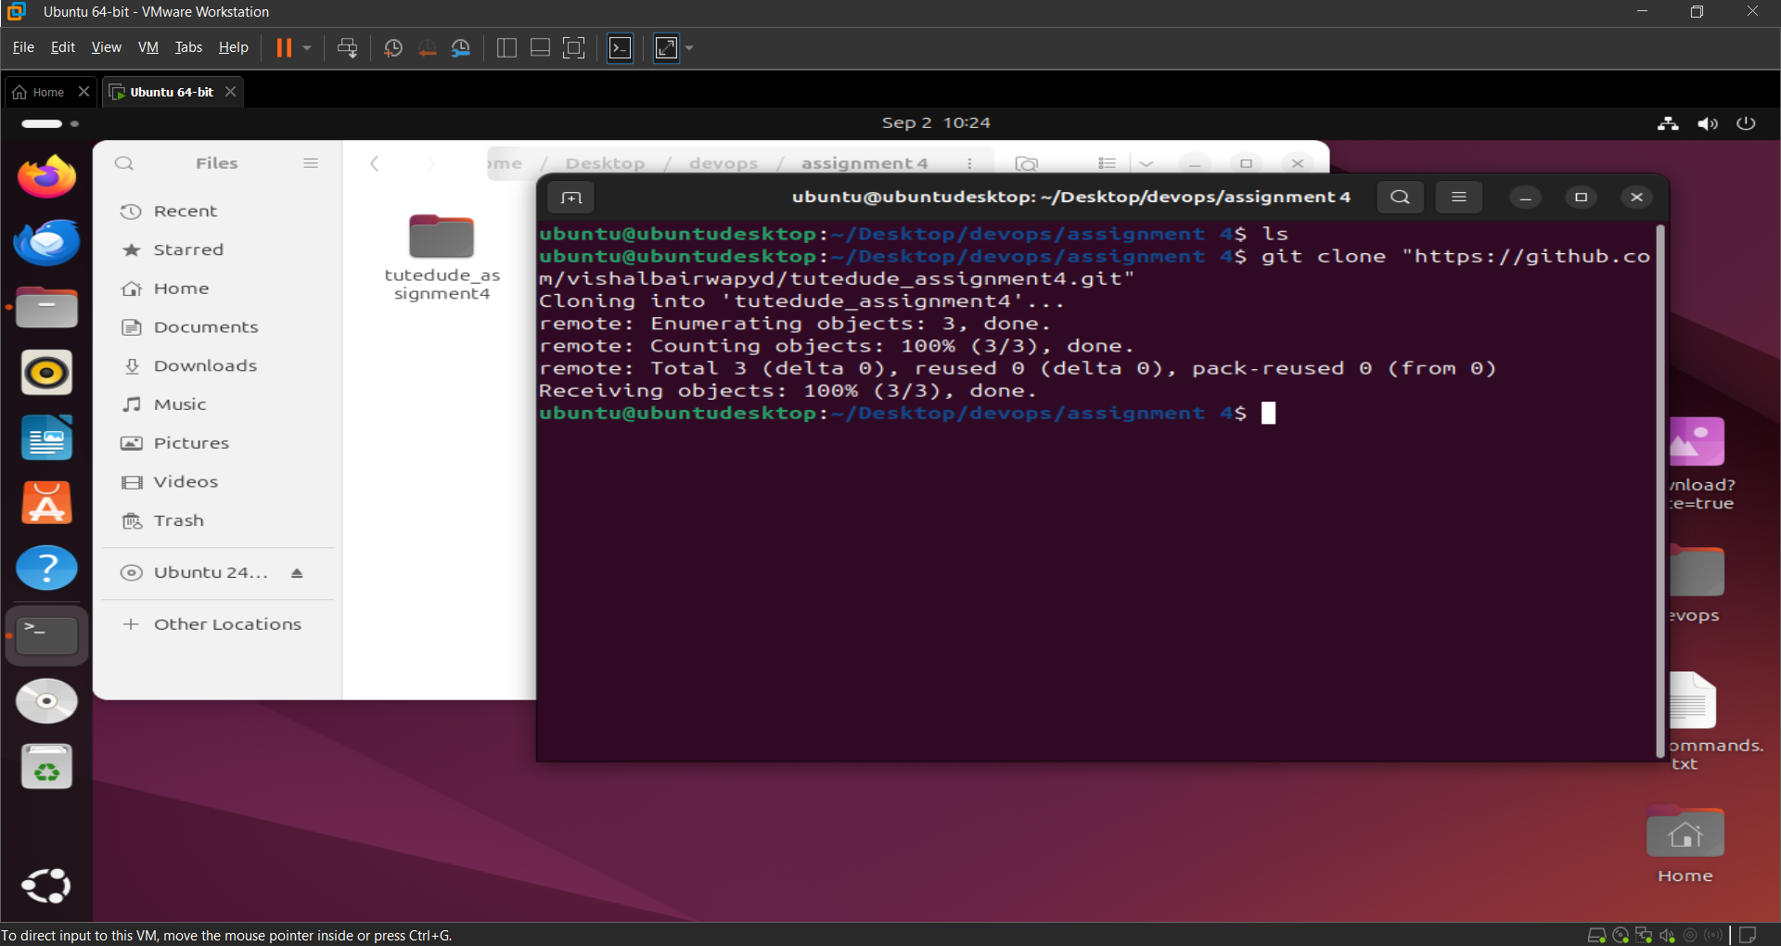

Step 4: Created a **new branch** named **“vishal”** locally.

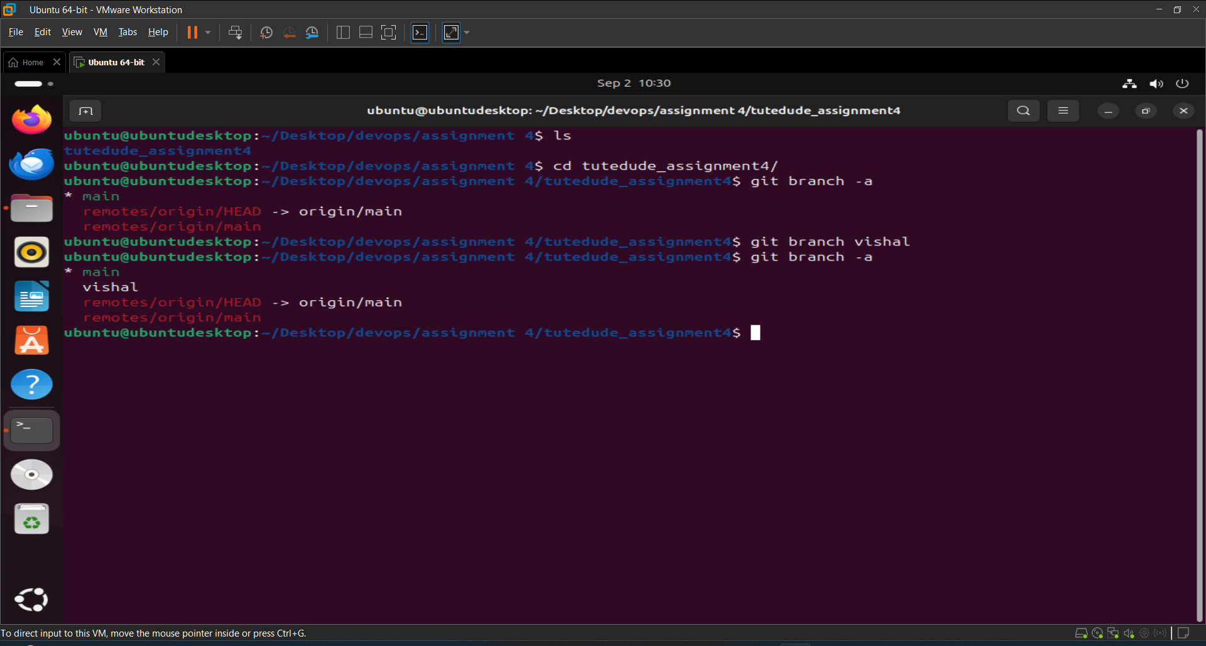

Step 5: Added my **project** content named **”web_app”** to this folder.

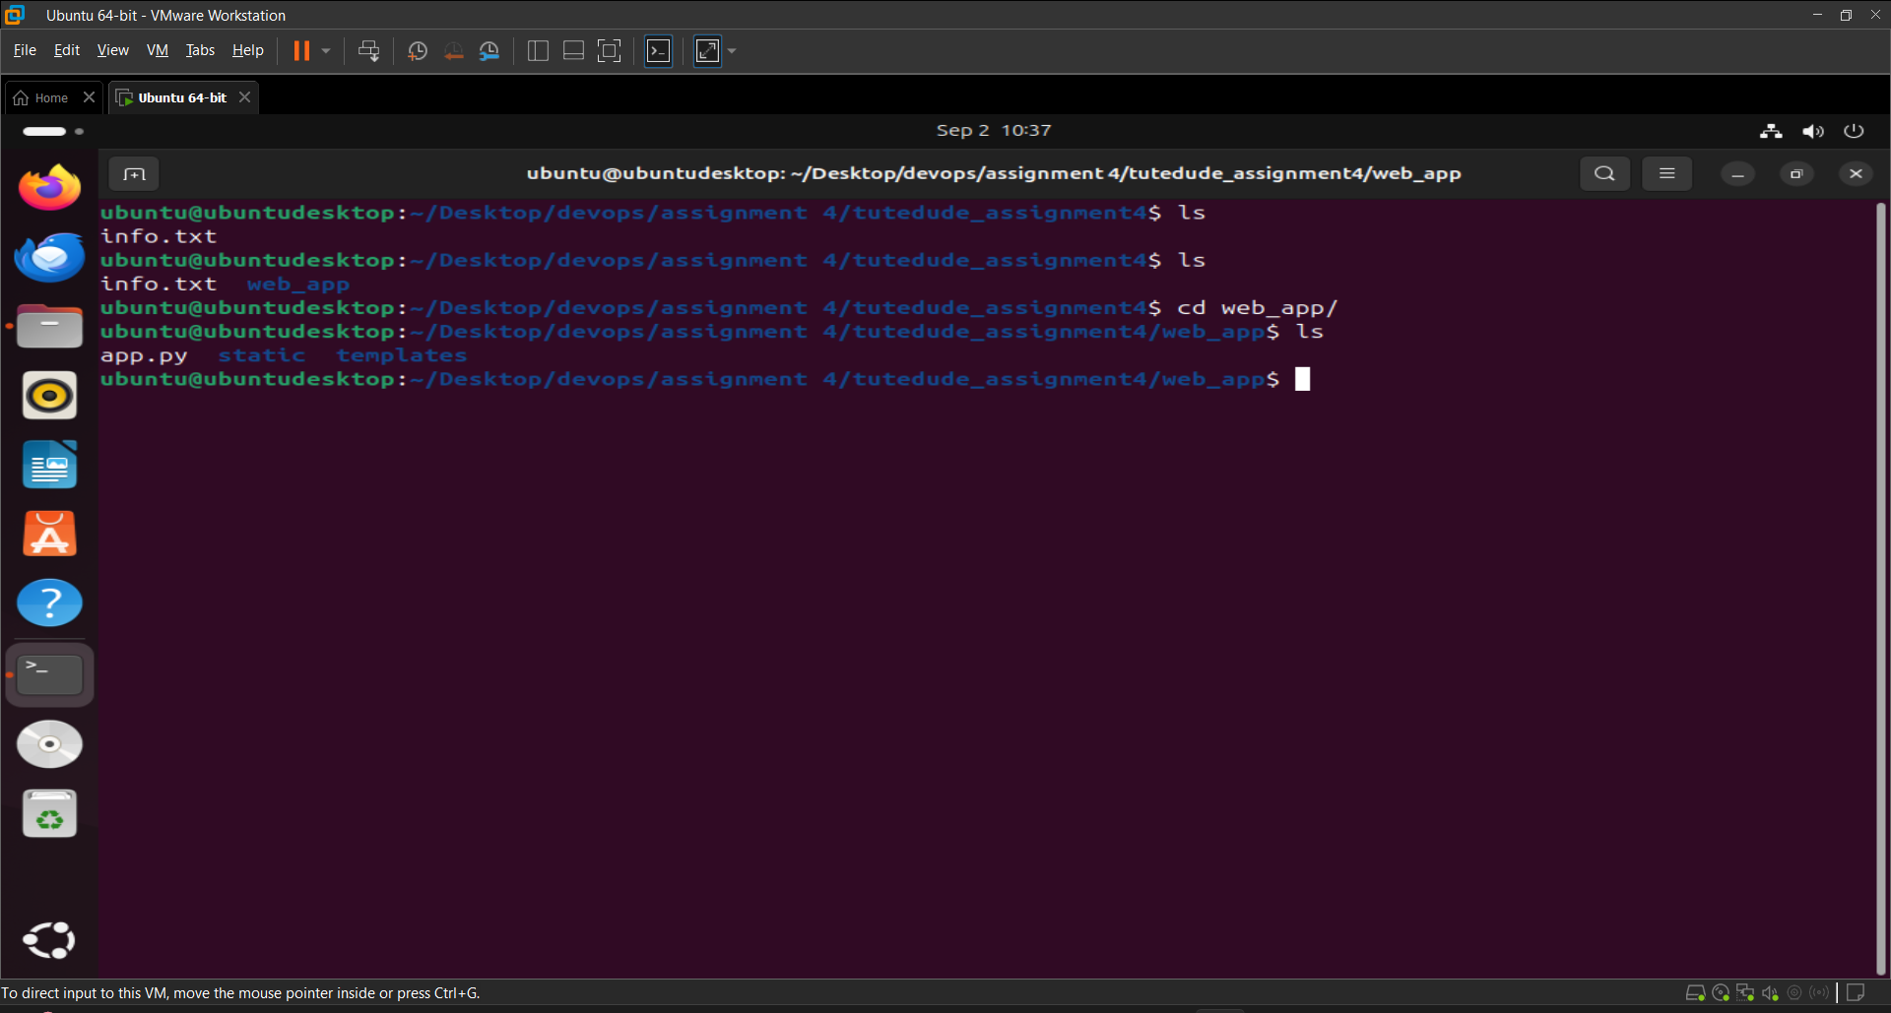

Step 5: Now add the **project “web_app”** to a newly created **branch named “vishal”** and commit it.

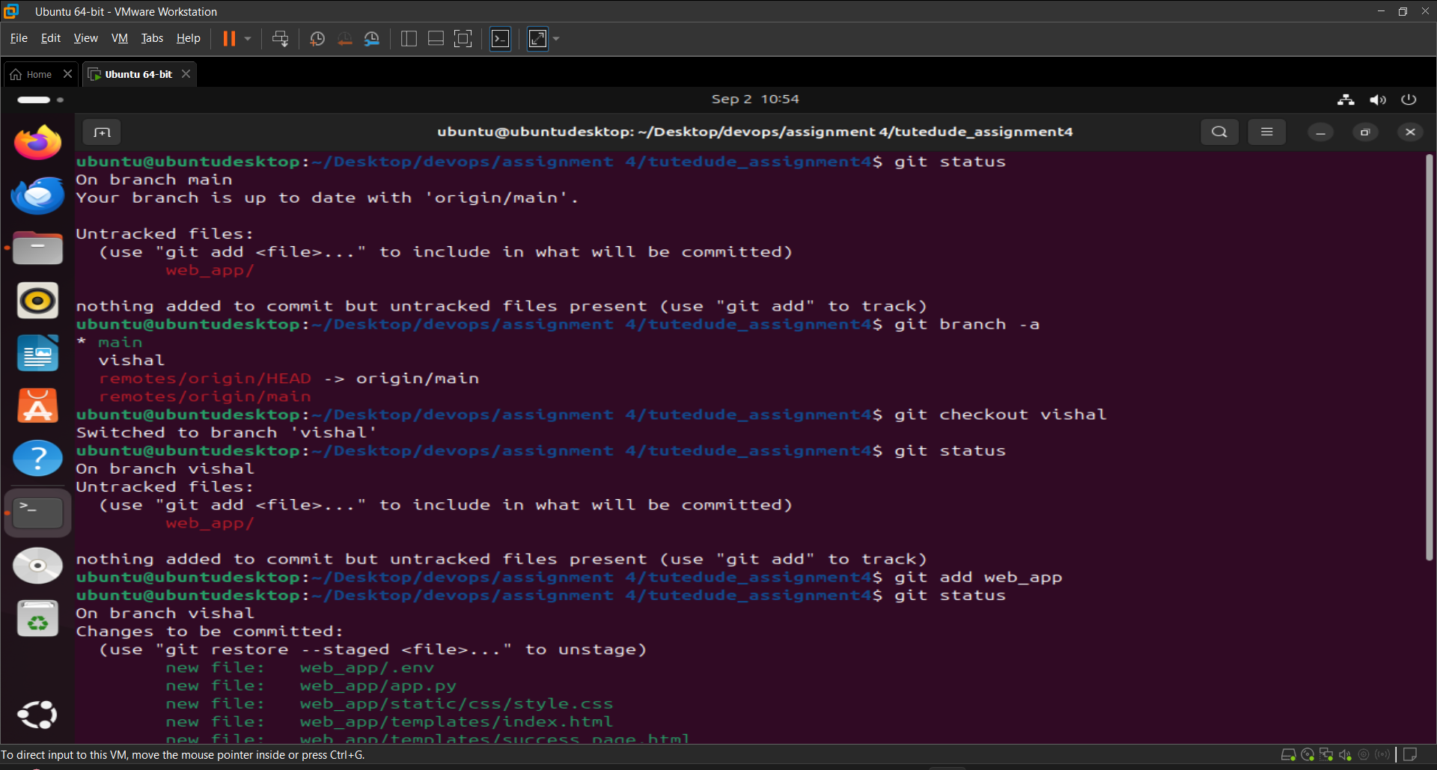

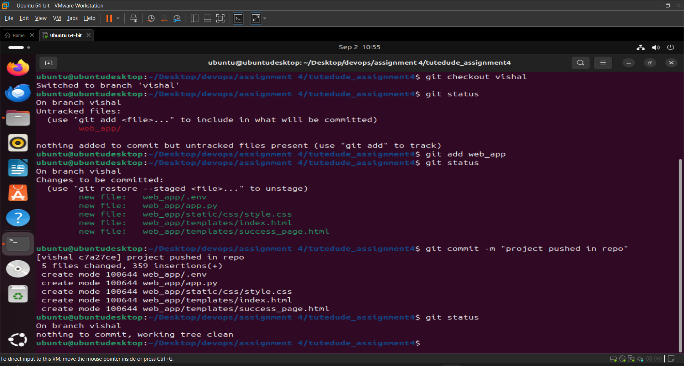

Step 6: Now **merge** “vishal” branch to “main” branch.

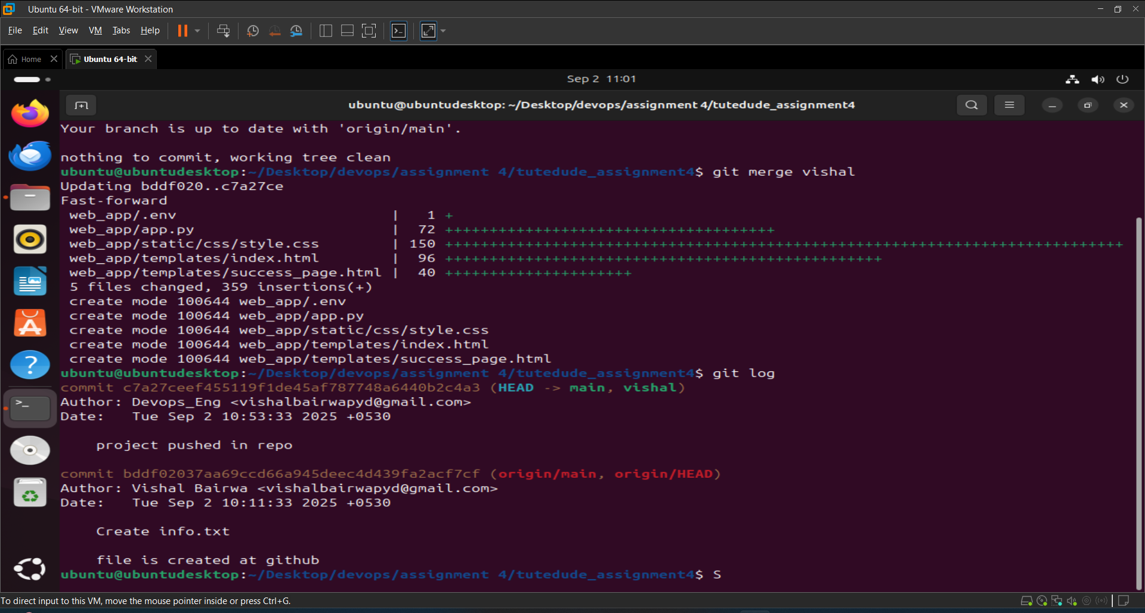

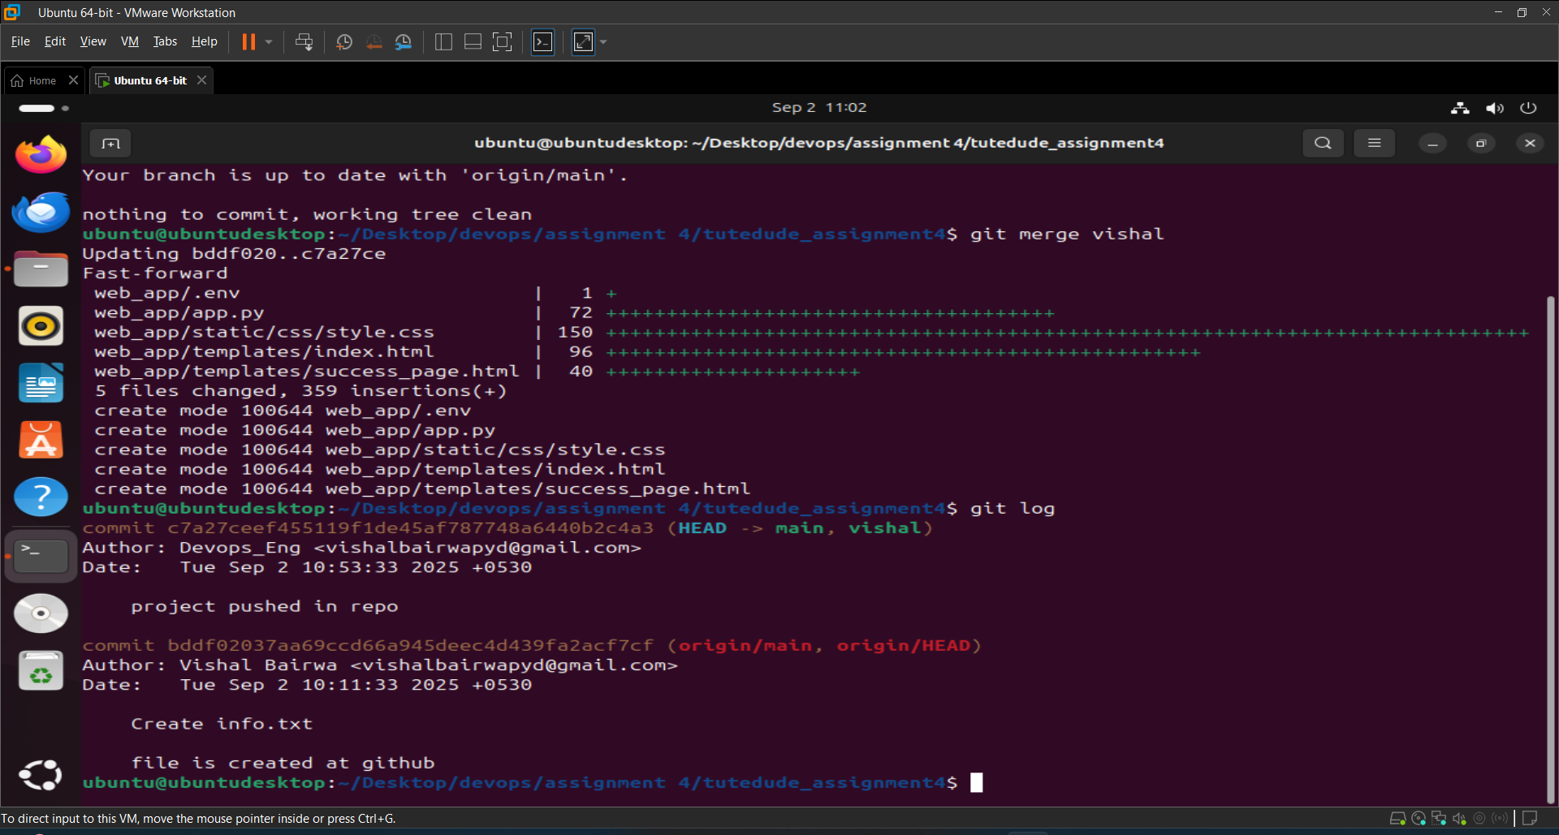

2. Create a new branch named <your_name>_new (e.g., Tutedude_new).

* Update the content of the JSON file used for the /api route in this branch.
* Merge the <your_name>_new branch into the main branch.
* If there are conflicts during the merge, resolve them by accepting the changes from the <your_name>_new branch.
* Add the resolved changes to the staging area, commit them, and push the updates to the remote repository.

Ans:

Step 1: Now **create a new branch** named **“vishal_new”** and switch in it.

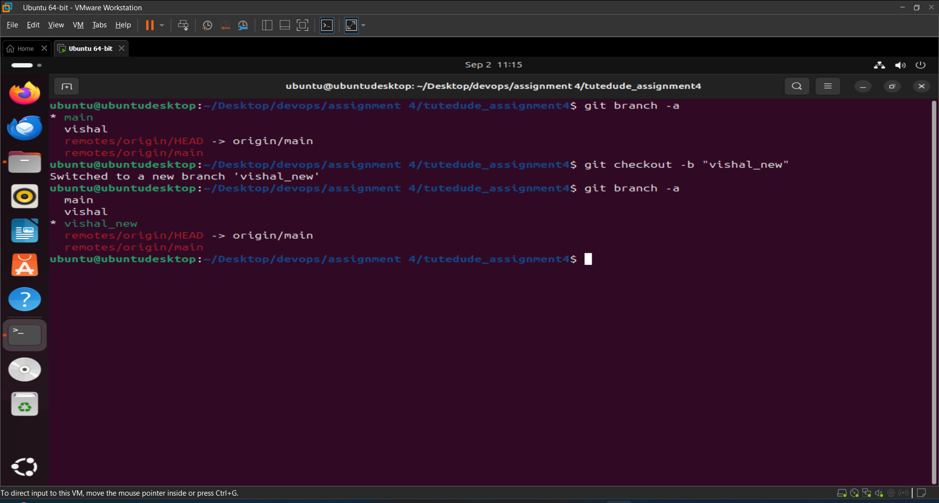

Step 2: Now add **“Update the content of the JSON file used for the /api route”** project within a **folder “web_app2”** in this directory and **commit “web_app2”** to **“vishal_new”** branch.

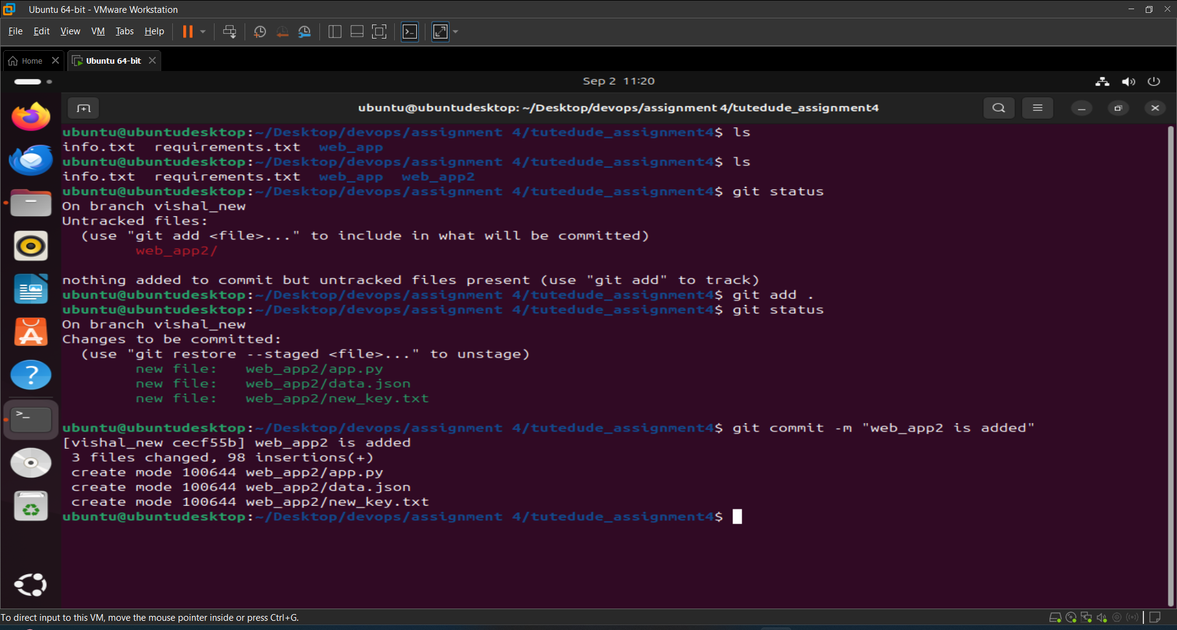

Step 3: **Merge** **“vishal_new”** branch with **“main”** branch.

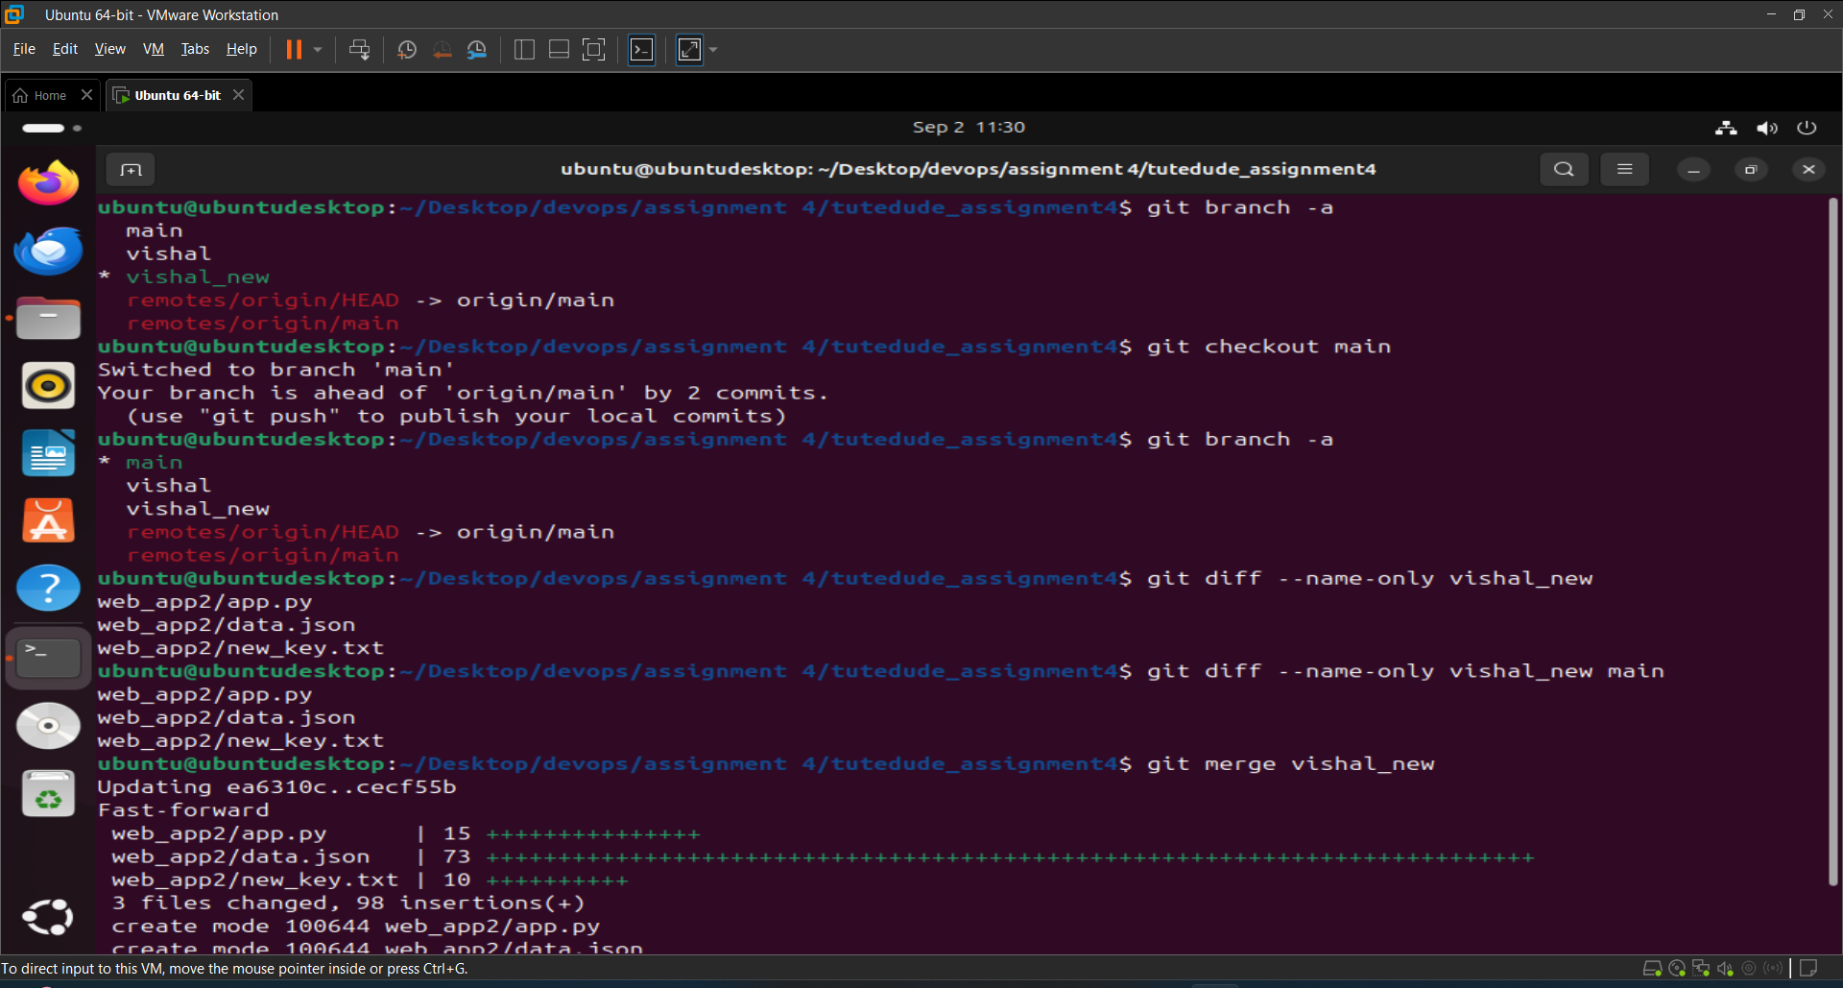

Step 4: Now push the changes to the remote repository.

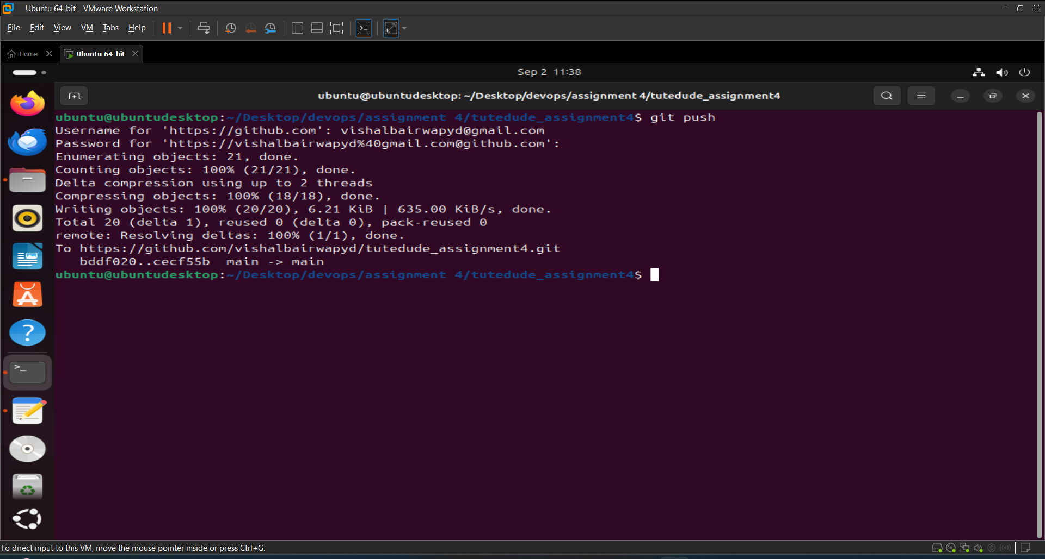

And on github you can see changes on the screenshot.

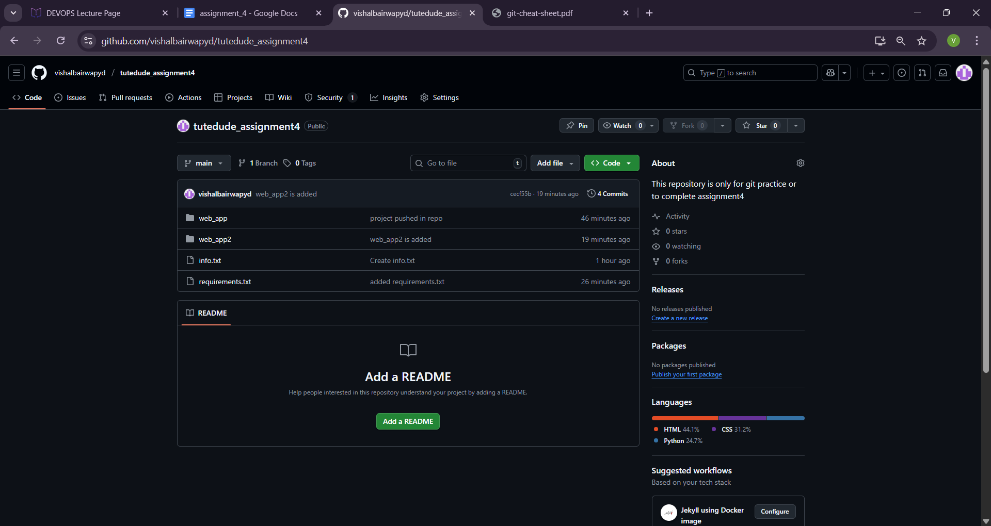

3. **Branch Creation**:

* Create two branches: master_1 and master_2 from the main branch.
* **Feature Development in** master_1:
* In the master_1 branch, create a **To-Do Page** in the frontend.
  + The page should contain a form with the following fields:
    - **Item Name**
    - **Item Description**
* **Backend API in** master_2:
* In the master_2 branch, create a backend route named /submittodoitem.
* This route will:
  + Accept itemName and itemDescription via a POST request.
  + Store these details in a MongoDB database.
* **Merging Changes**:
* Merge the changes from both master_1 and master_2 into the main branch.

Ans:

Step 1: Two new branches created master_1 and master_2 from the main branch.  
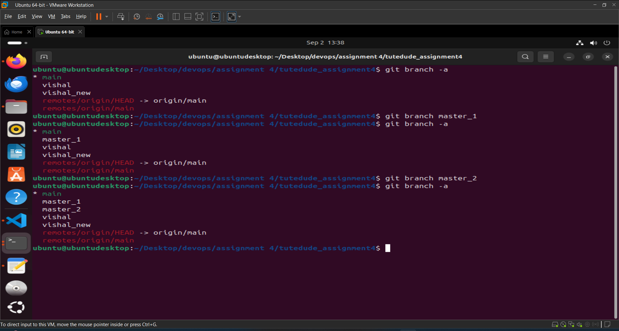

Step 2: Now I created a sub directory “frontend ” inside the "development" directory and added an “[app.py](http://app.py)” file that contains python code to run the ui part of the app and “template” folder that consists a “to-do.html” file.

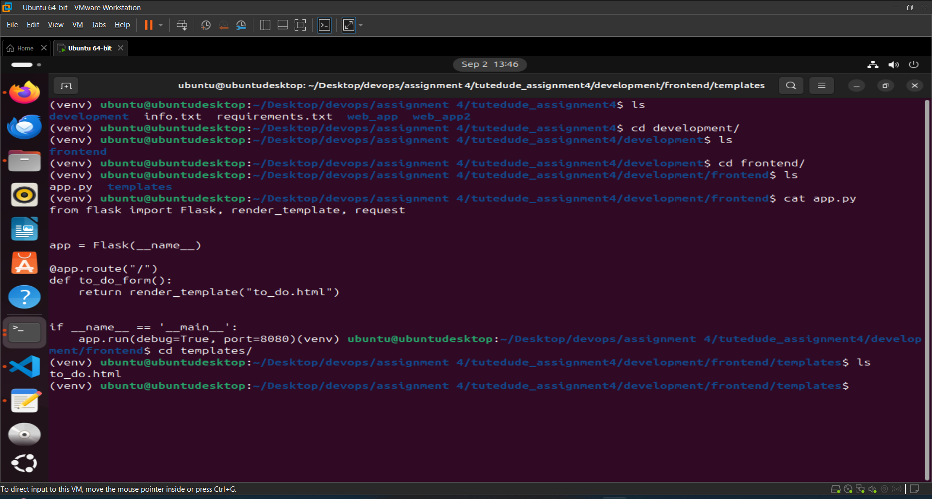

Step 3: Now run our “[app.py](http://app.py)” file to start the project and show the user interface.

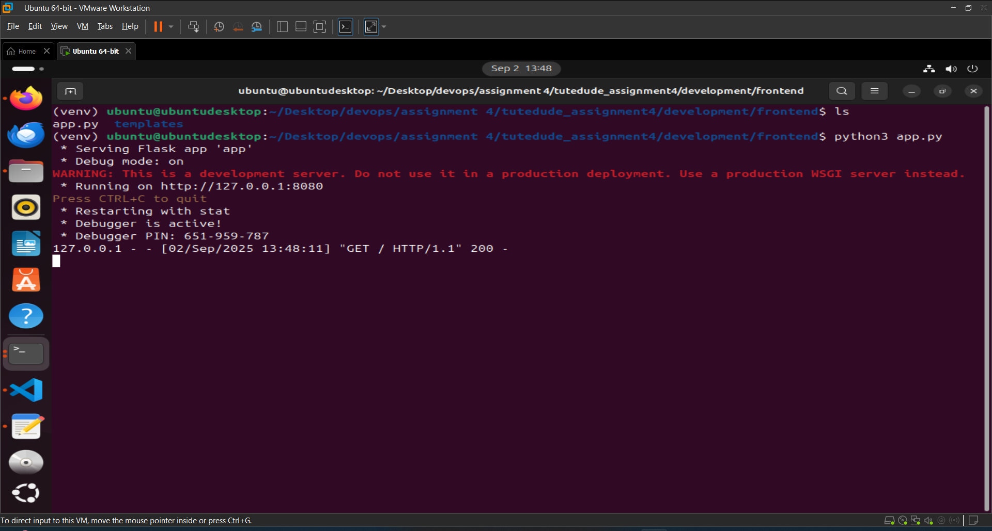

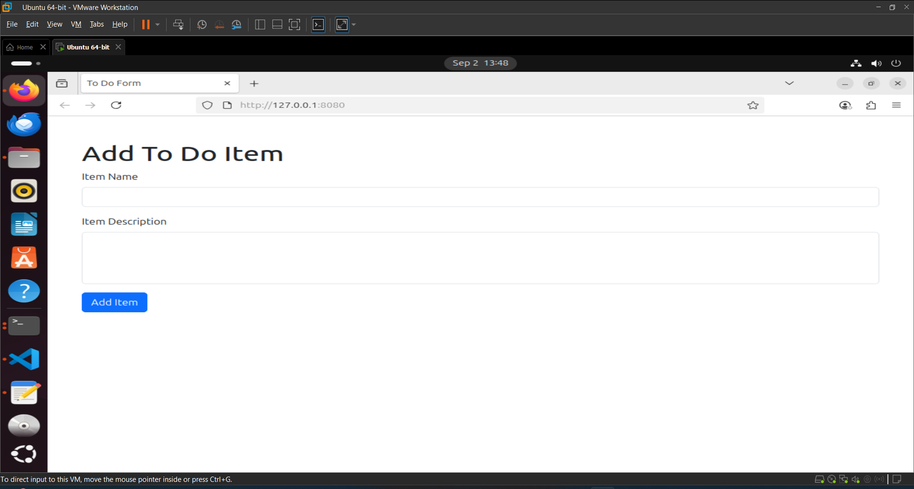

Step 4: Now commit the changes in master_1 branch.

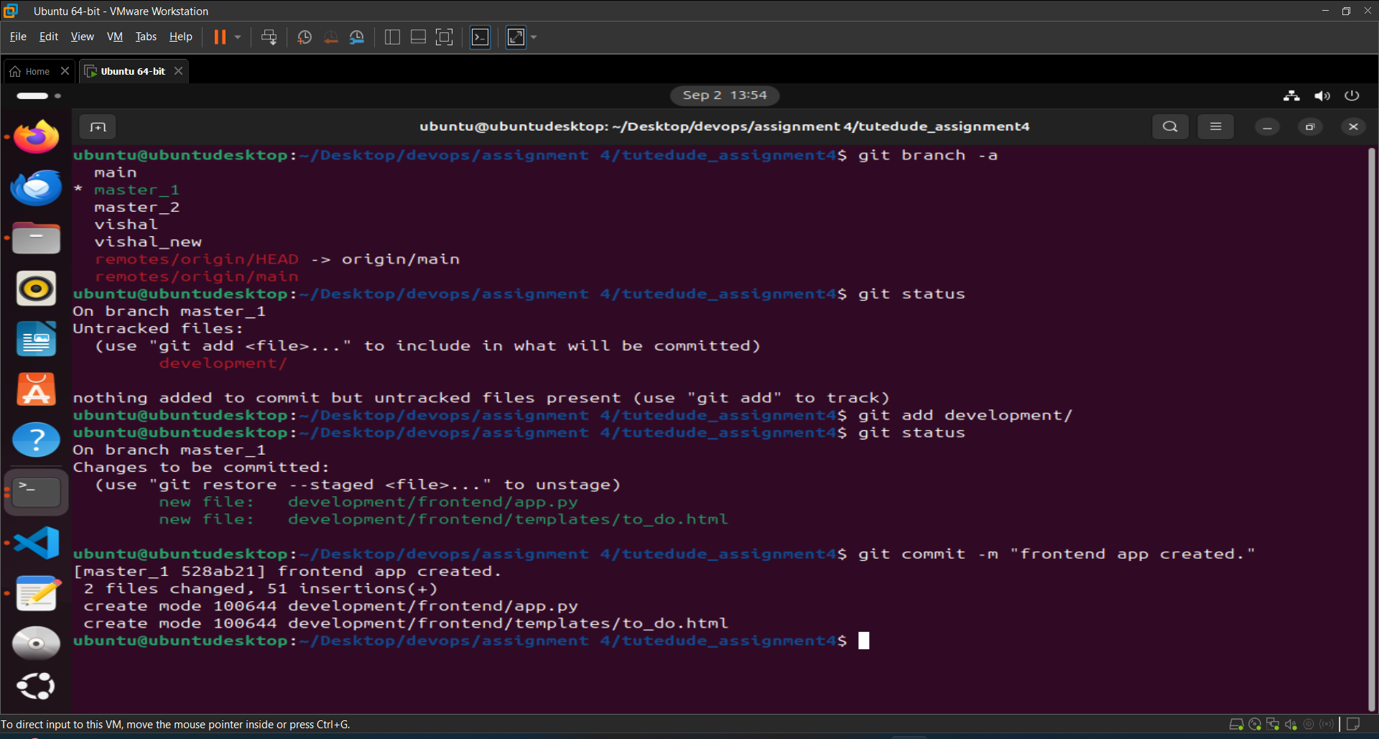

Step 5: Now switch master_2 branch and start working on the “backend” api route.

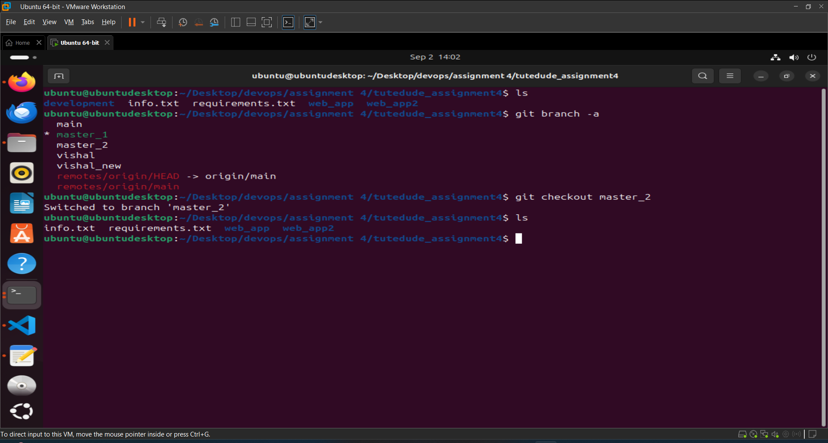

Step 6: Now I created a sub directory “backend ” inside the "development" directory and added an “[app.py](http://app.py)” file that contains python code with route named “/submittodoitem”.

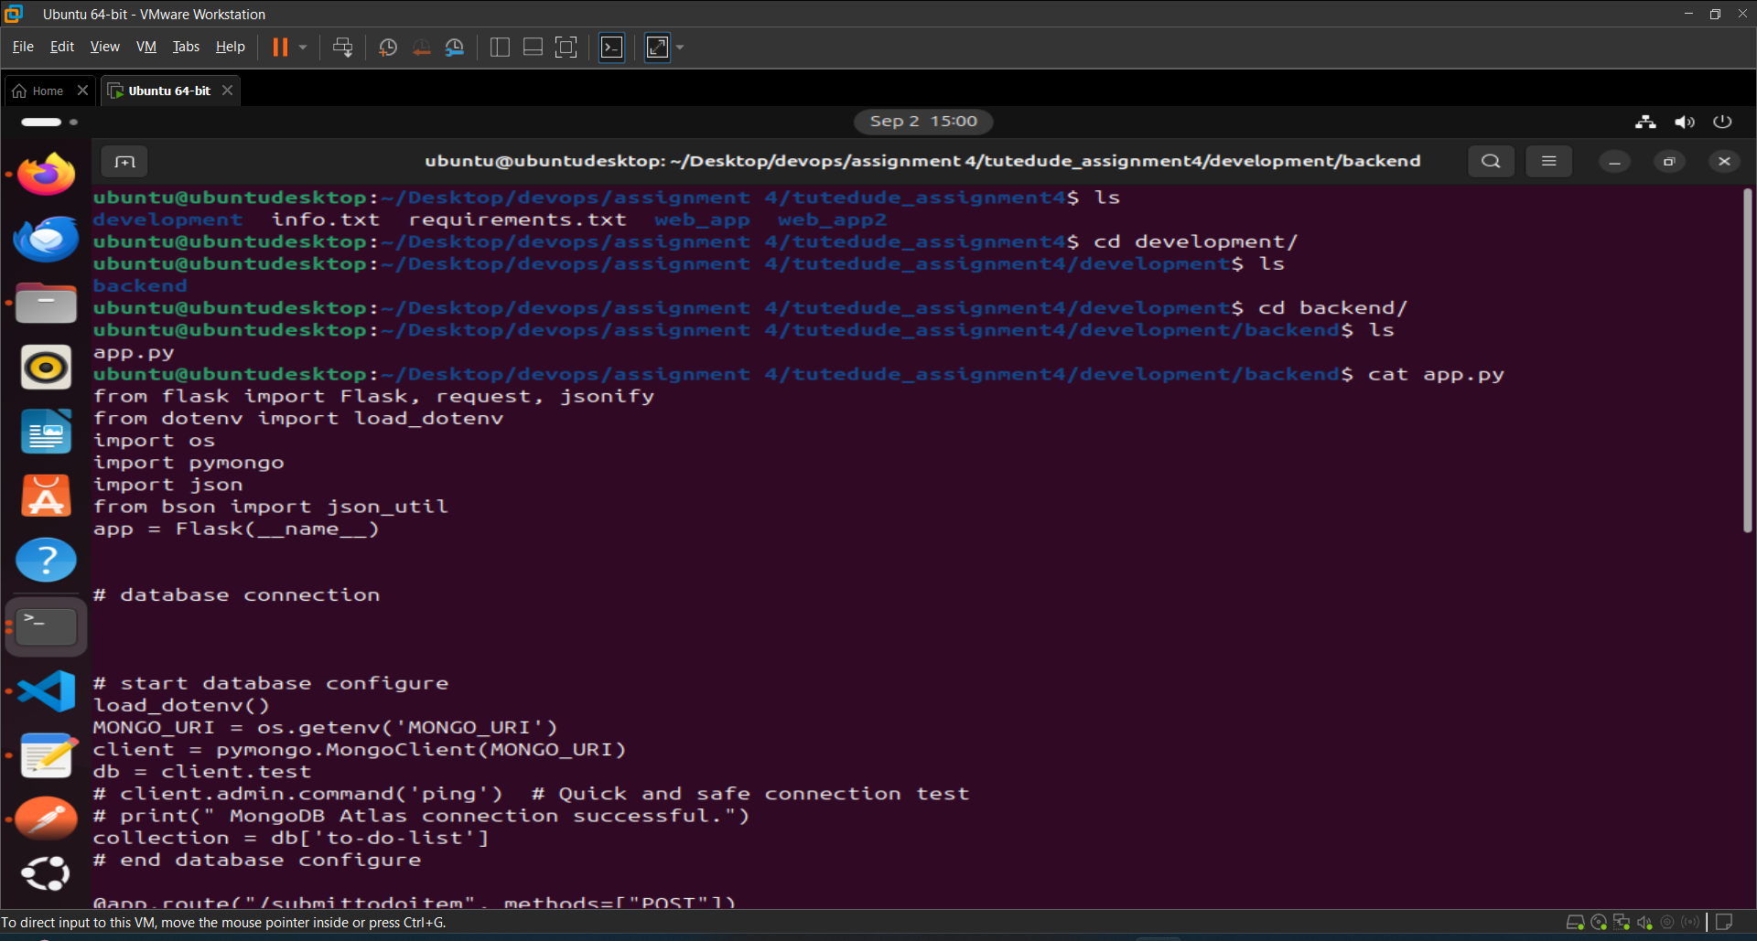

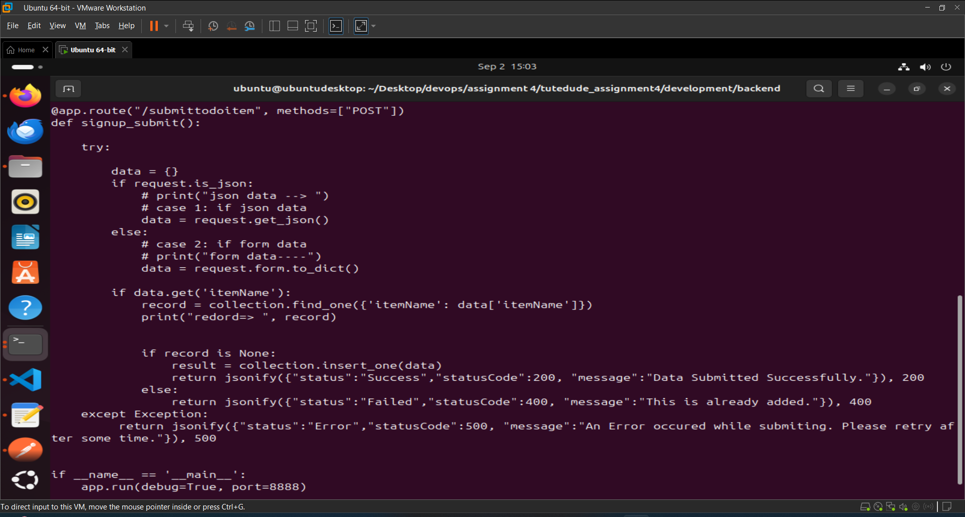

Step 7: Now run our “[app.py](http://app.py)” file to check the project working properly.

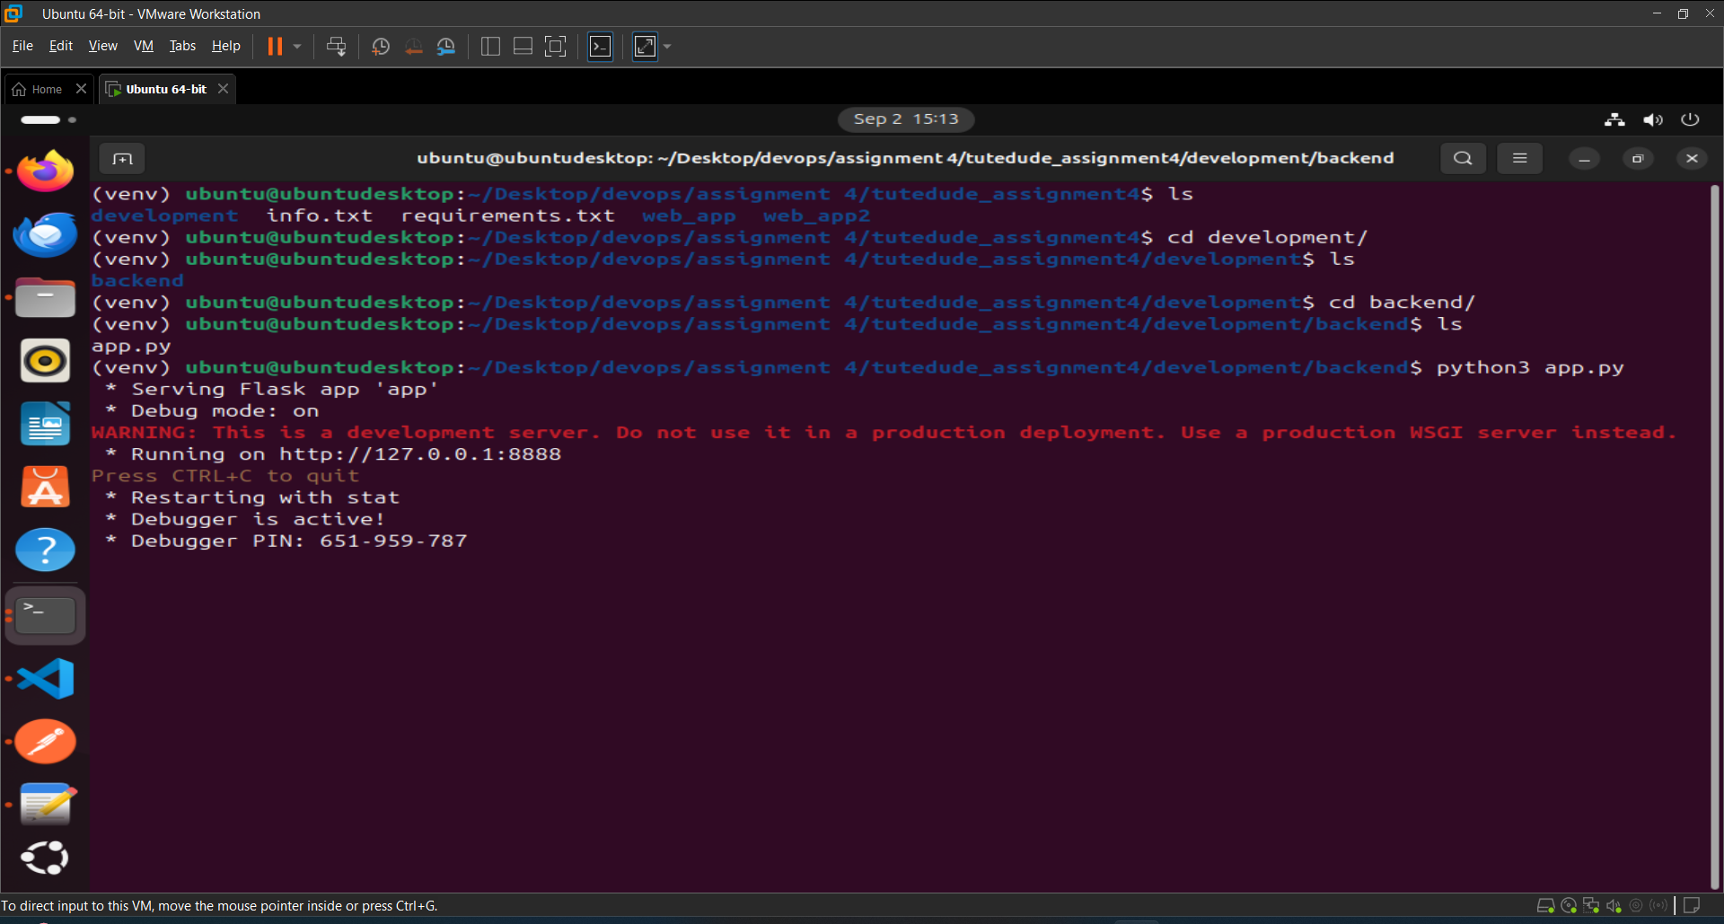

1. Test the api route in “Postman”.

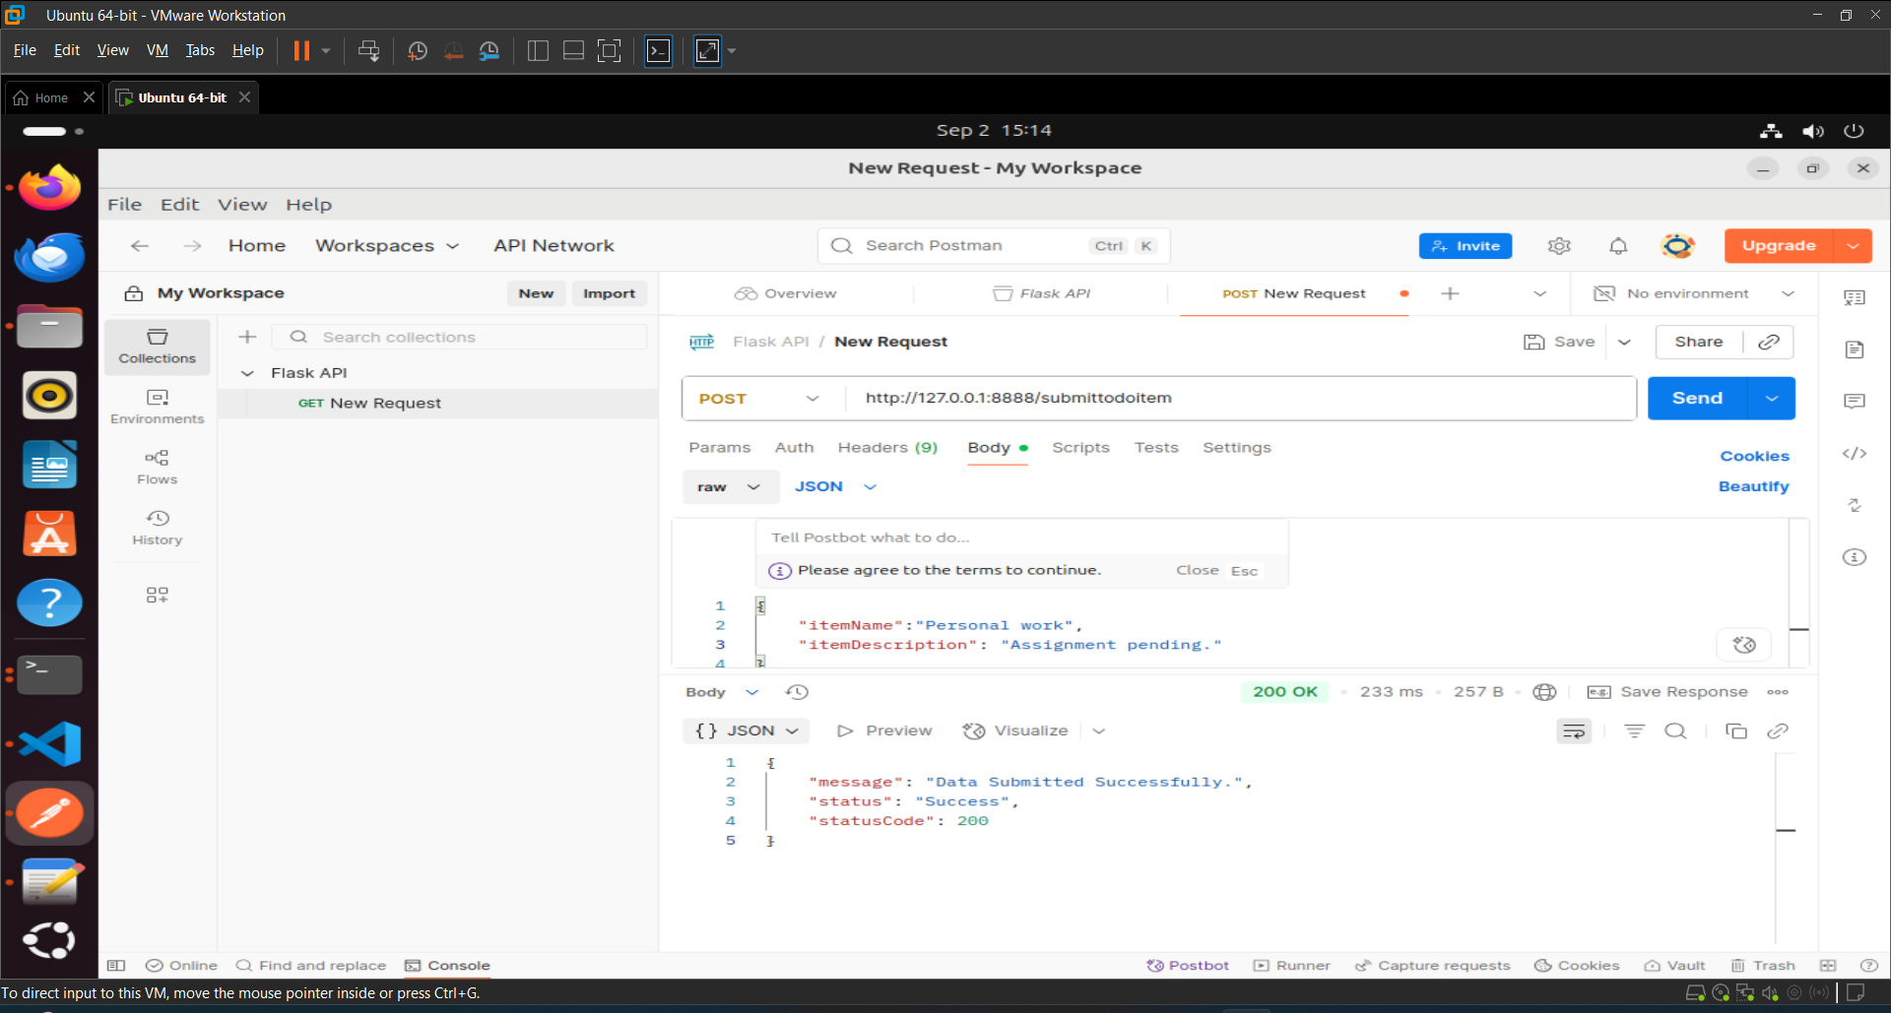

1. End point run successfully now check data save in the database or not. As you can see data is also saved successfully.

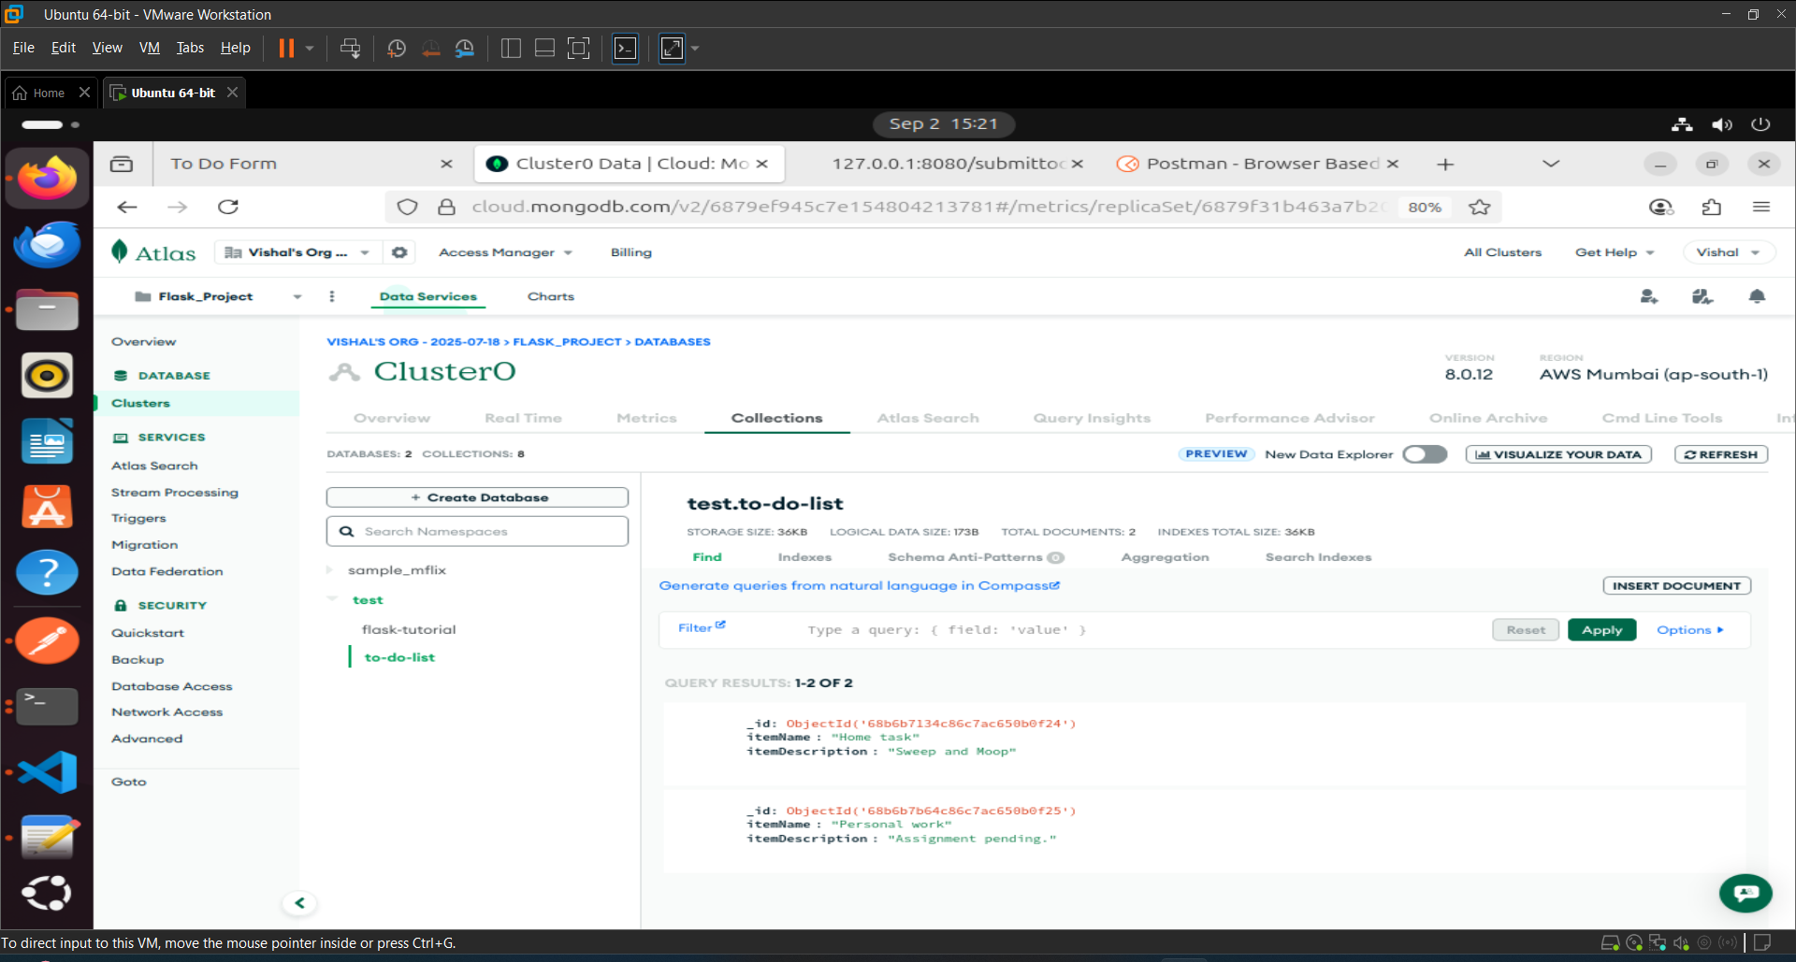

Step 8: Now commit the changes in master_2 branch.

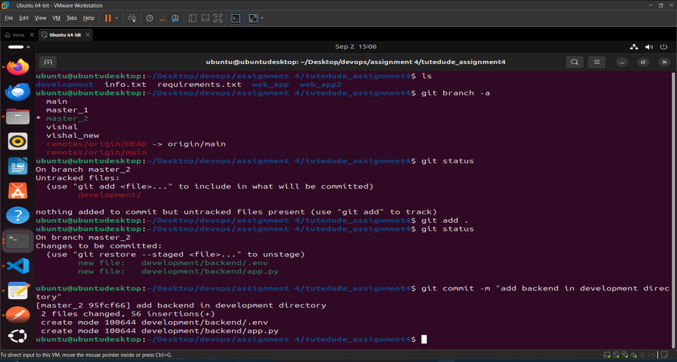

4. **Enhancing the To-Do Form in** master_1:

* In the master_1 branch, add the following fields to the To-Do form:
  + **Item ID**
  + **Item UUID**
  + **Item Hash**
* **Committing in Sequence**:
* Add and commit each field separately in the following order:
  + **First commit**: Add **Item ID** field.
  + **Second commit**: Add **Item UUID** field.
  + **Third commit**: Add **Item Hash** field.
* **Merging to** main:
* Merge the master_1 branch into the main branch.
* **Git Reset and Commit Deletion**:
* In the main branch, use **Git Reset** to roll back to the commit where only the **Item ID** field was added.
* Use git reset --soft to ensure changes remain staged.
* Re-commit this state to the main branch.
* Merge this updated state to the main branch.
* **Rebasing Changes**:
* Rebase the updated changes in the main branch to the master_1 branch.  
  **Clarification**:
  + During rebasing, **preserve individual commits** to maintain the commit history for each change (i.e., do not squash commits).
  + Use git rebase main master_1 to integrate changes from the main branch back into the master_1 branch.

Ans:

Step 1: Now add the first field **“Item ID”** in “to-do.html” and commit it.

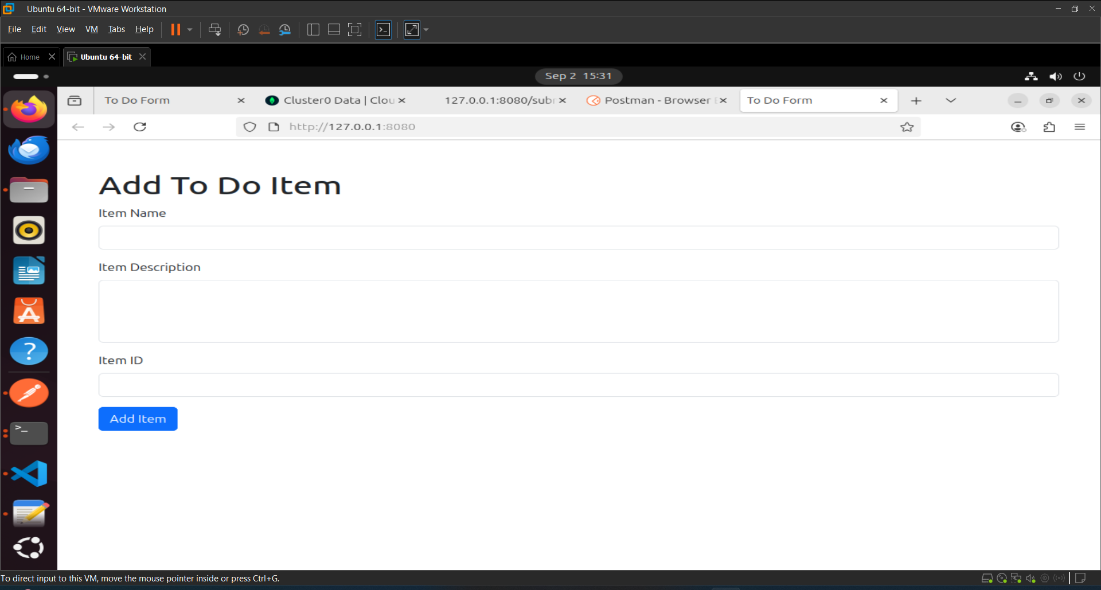

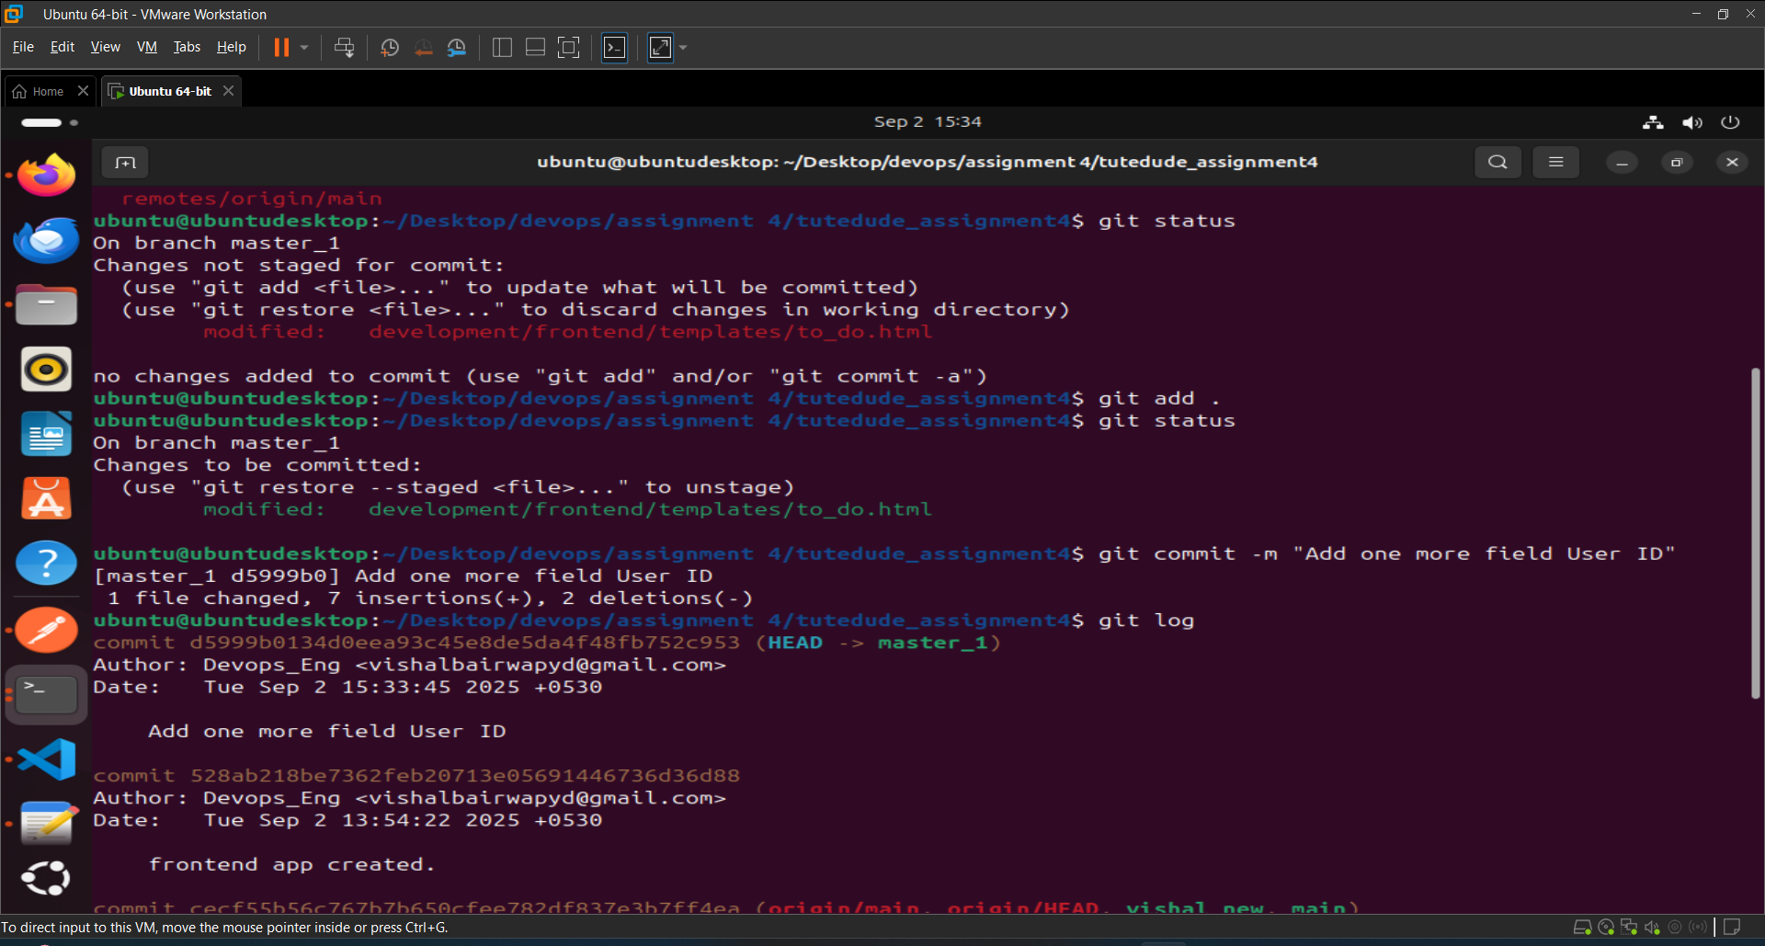

Step 2: Now add the Second field **“Item UUID”** in “to-do.html” and commit it.

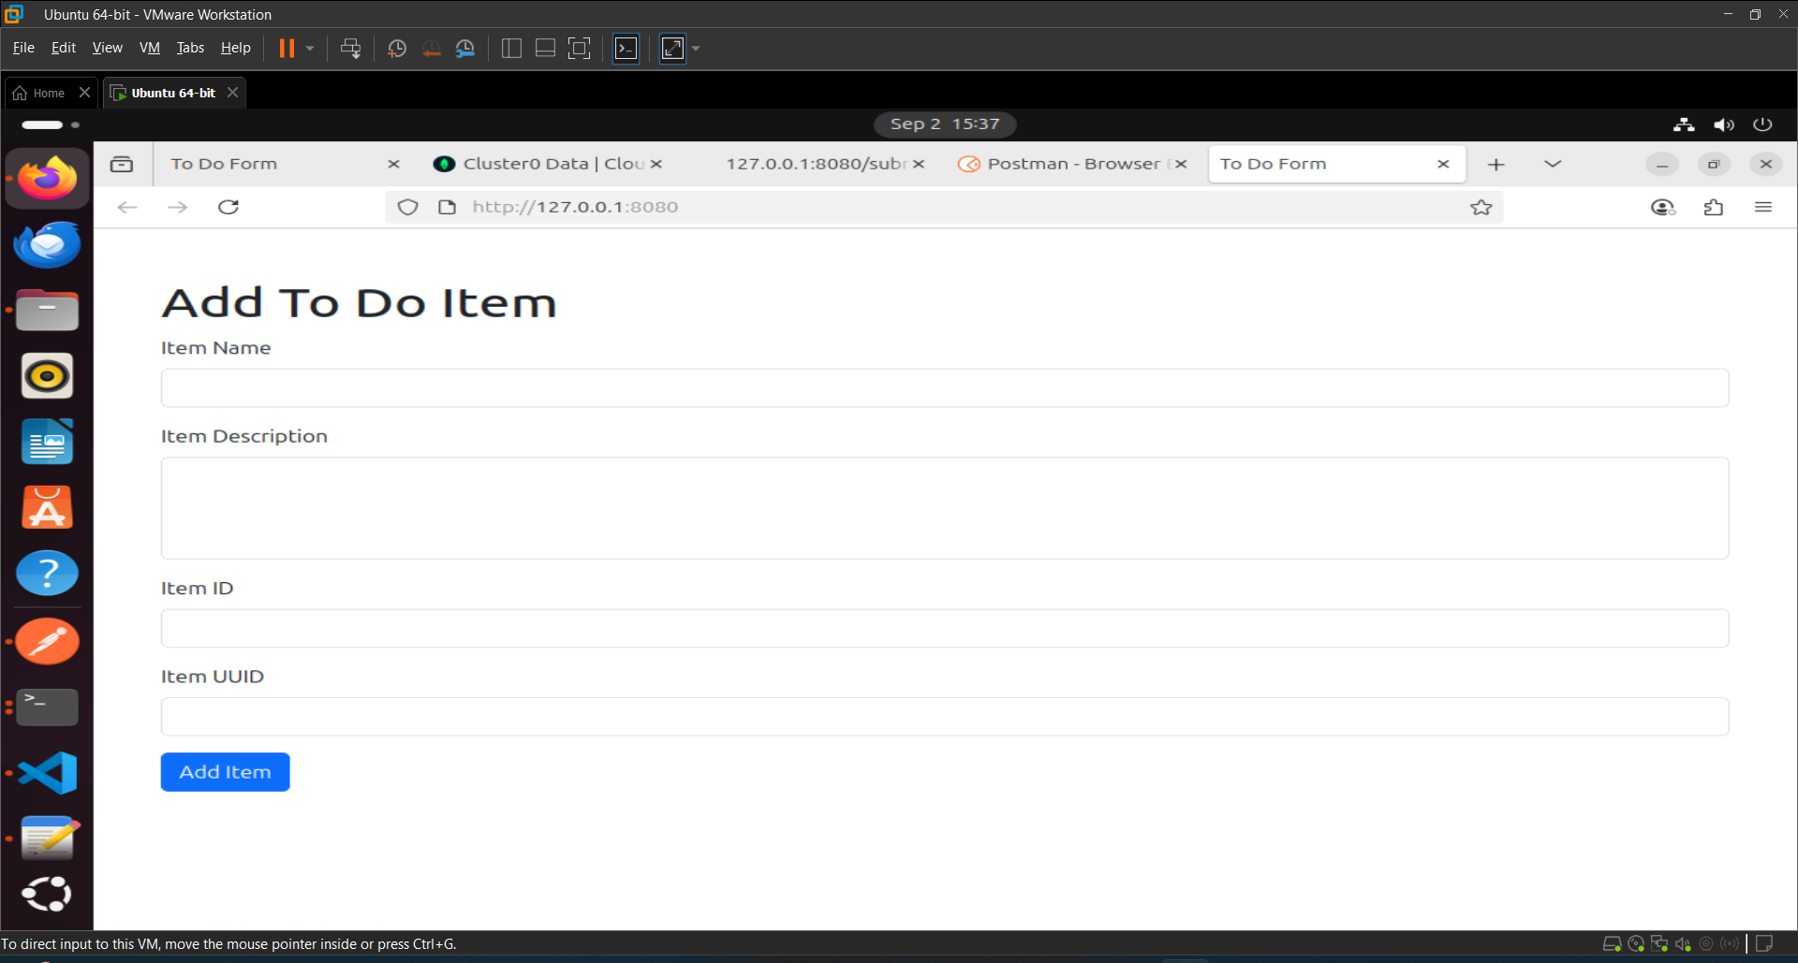

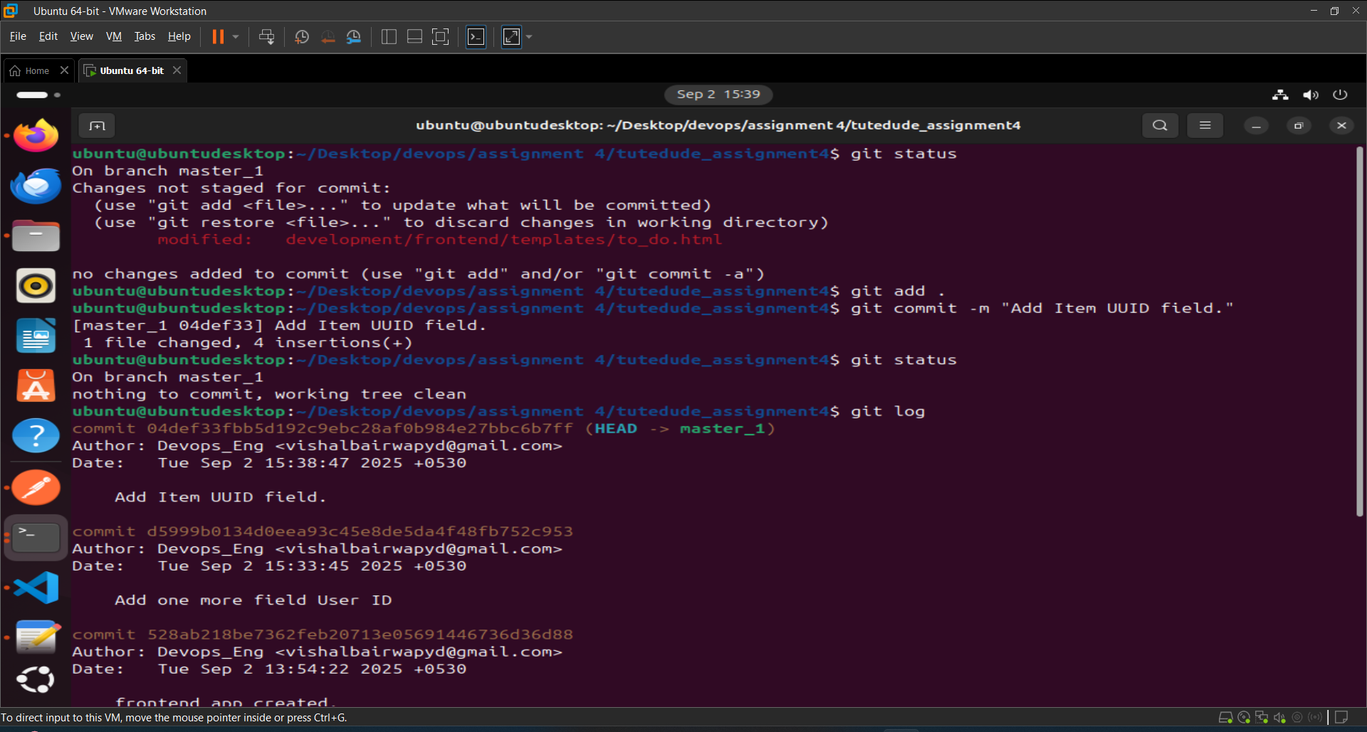

Step 3: Now add the Second field **“Item Hash”** in “to-do.html” and commit it.

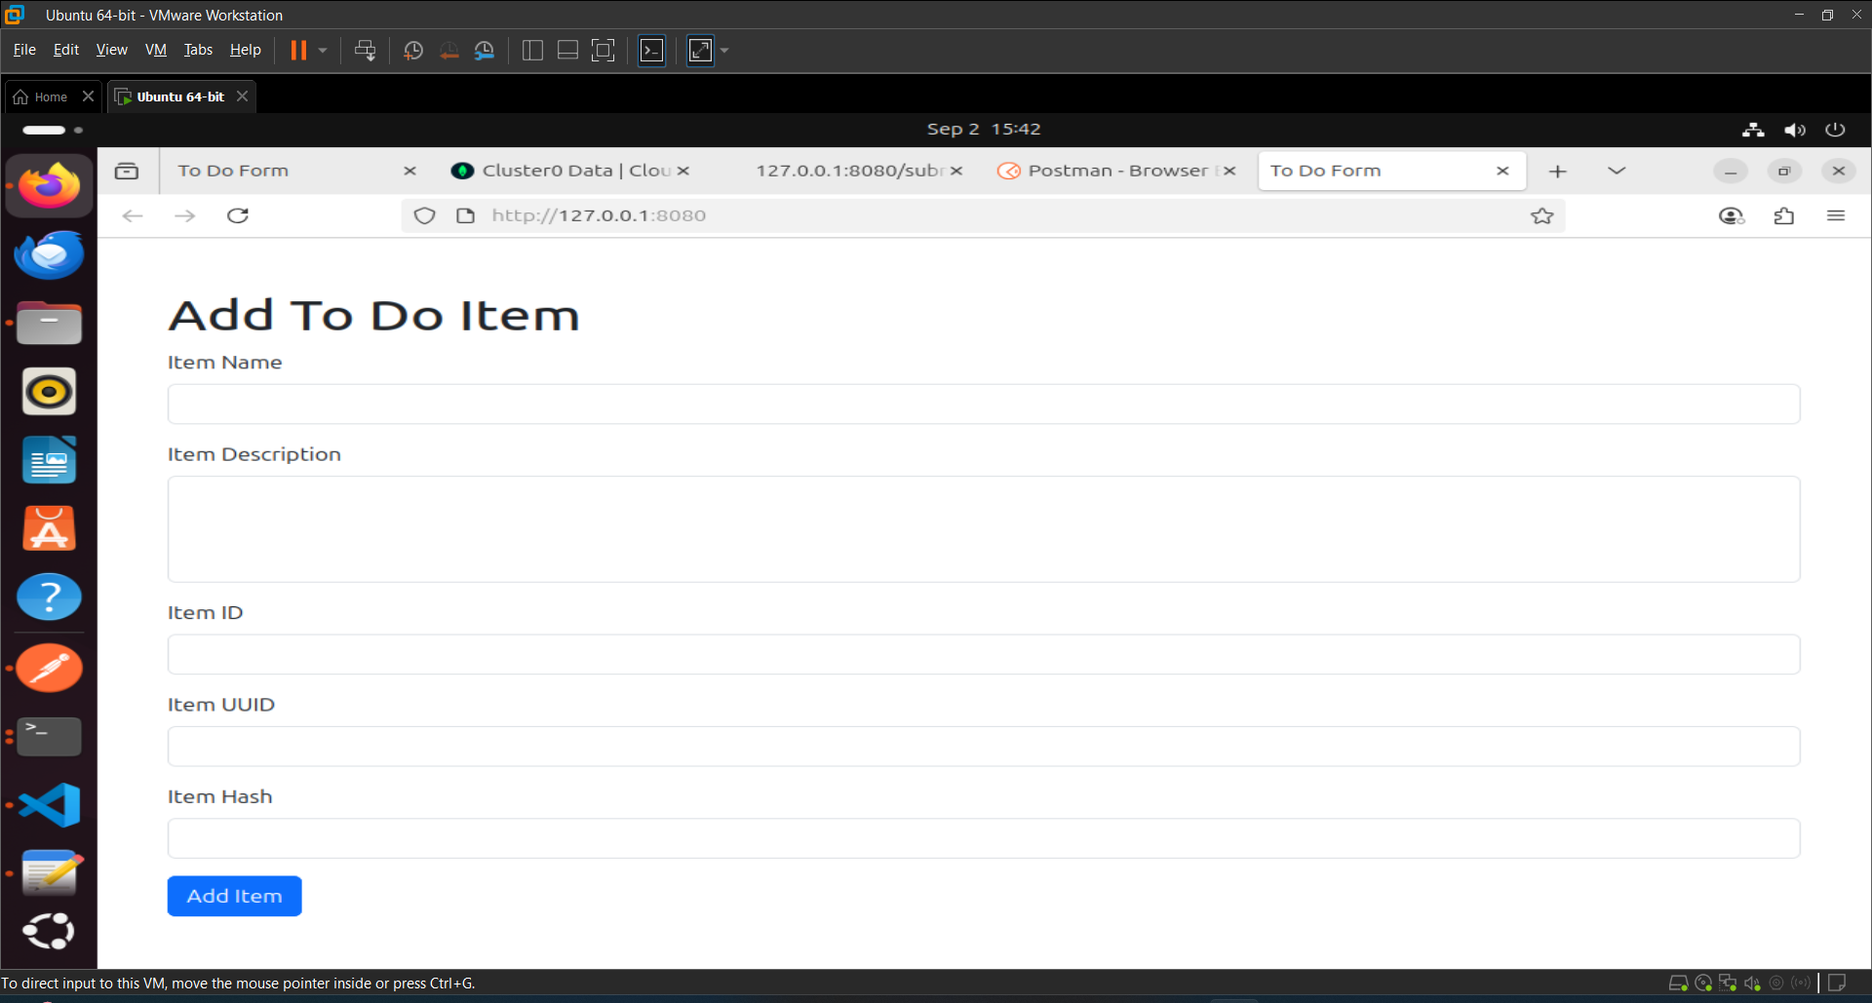

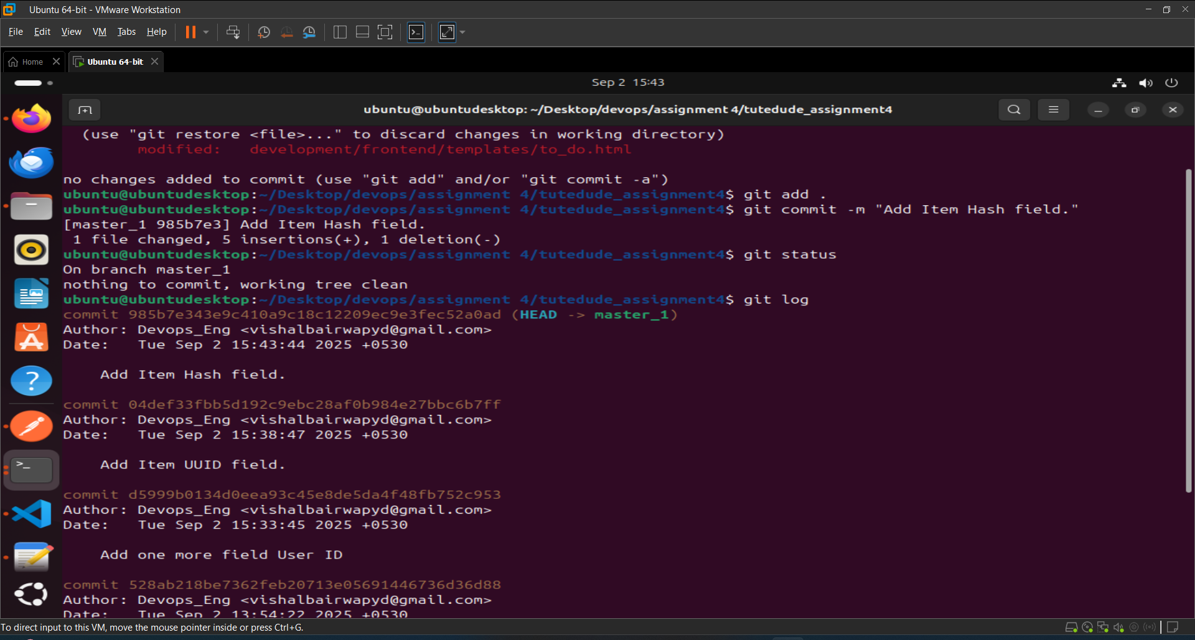

Step 4: Merged the master_1 branch into the main branch.

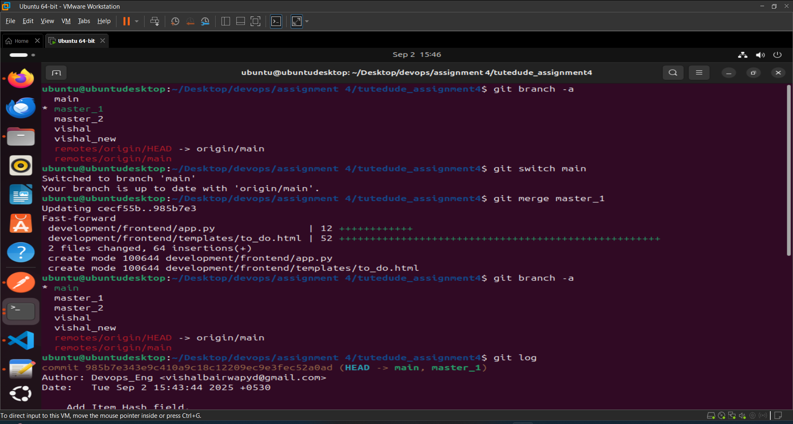

Step 5: We use soft **Git Reset** to roll back to the commit where only the **Item ID** field was added.

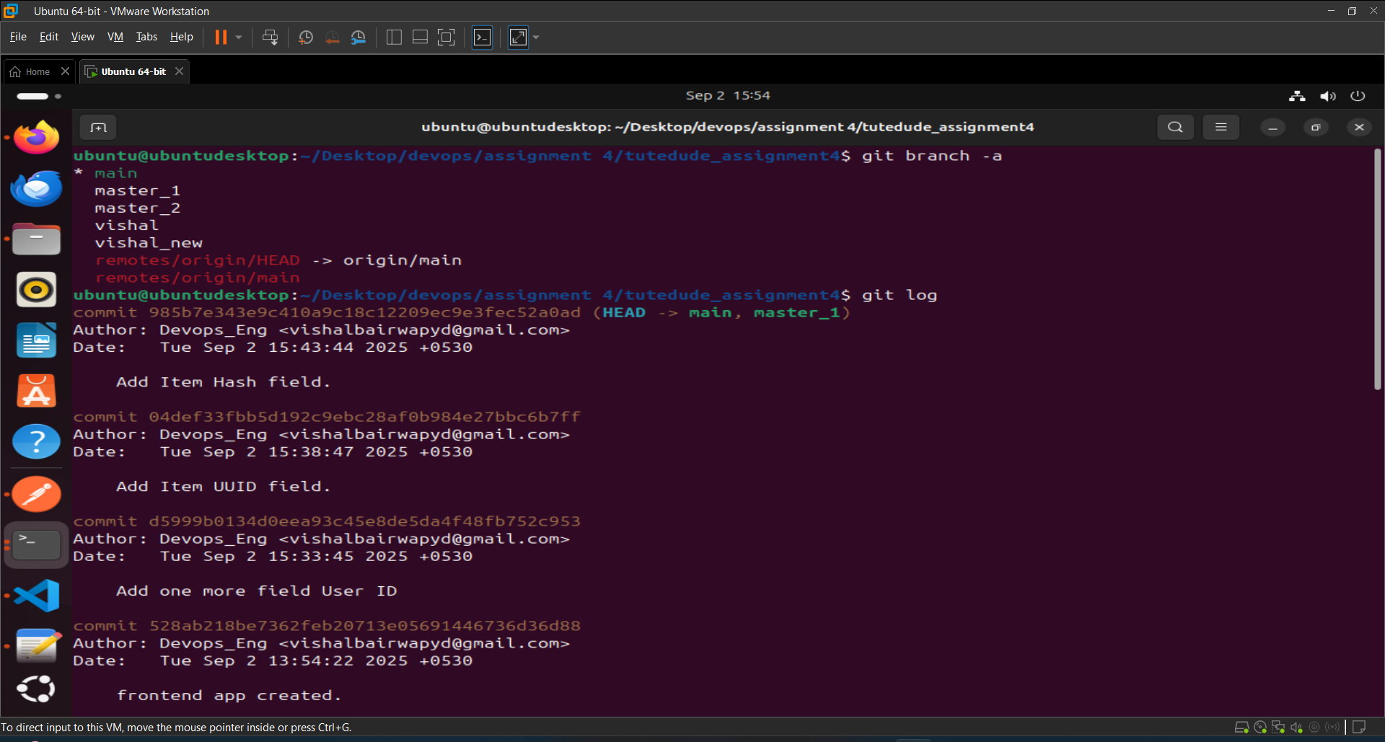

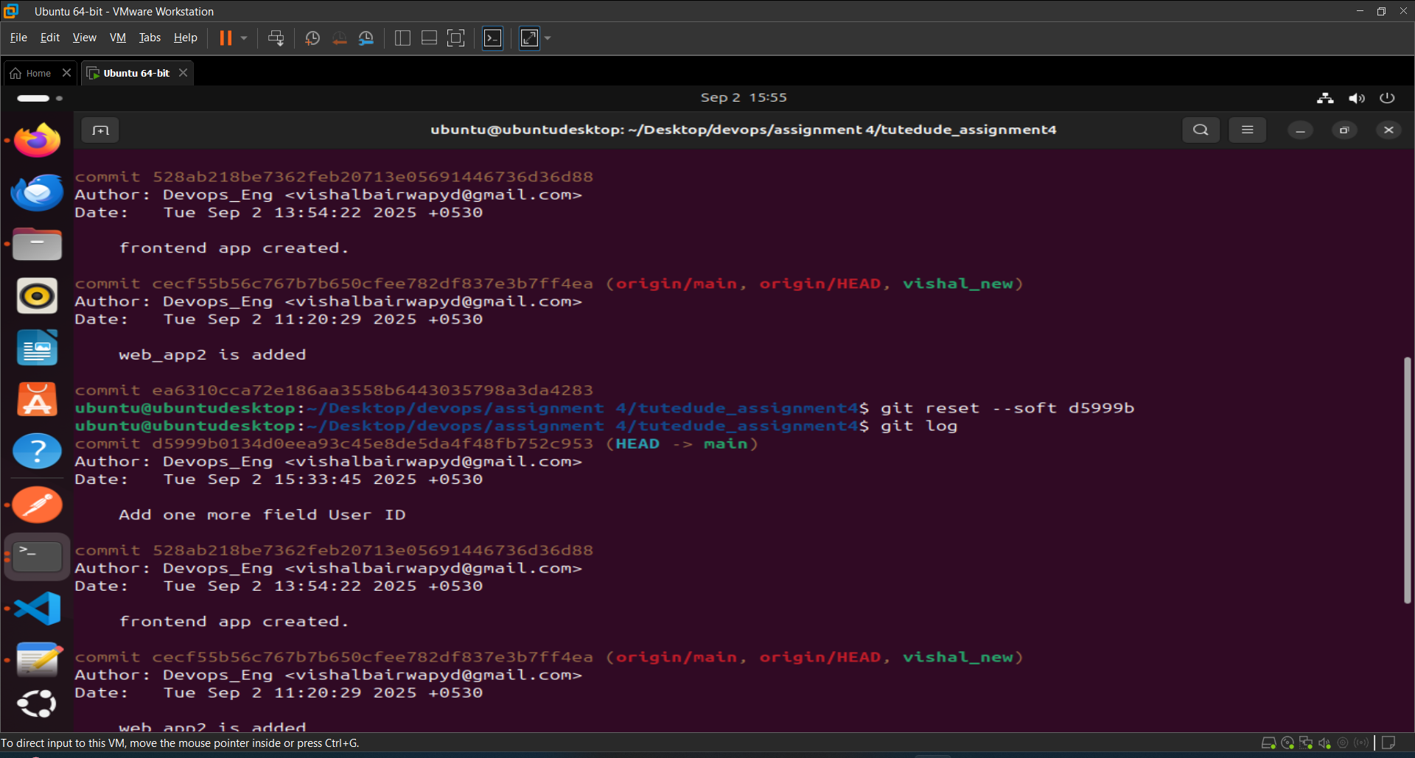

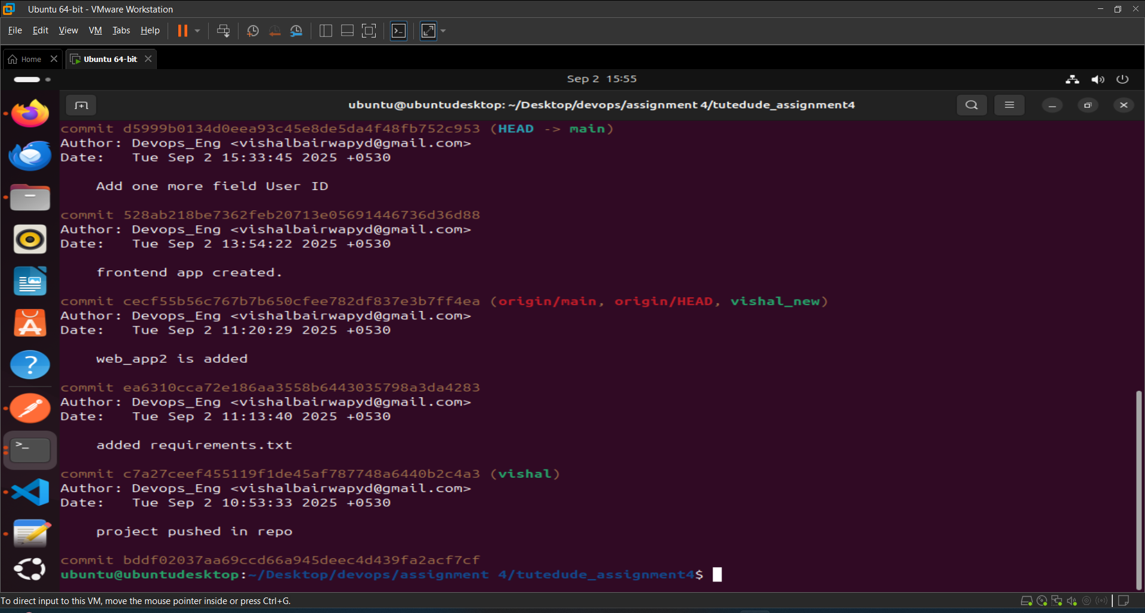

Step 6: Now re-commit this reset state to the main branch.

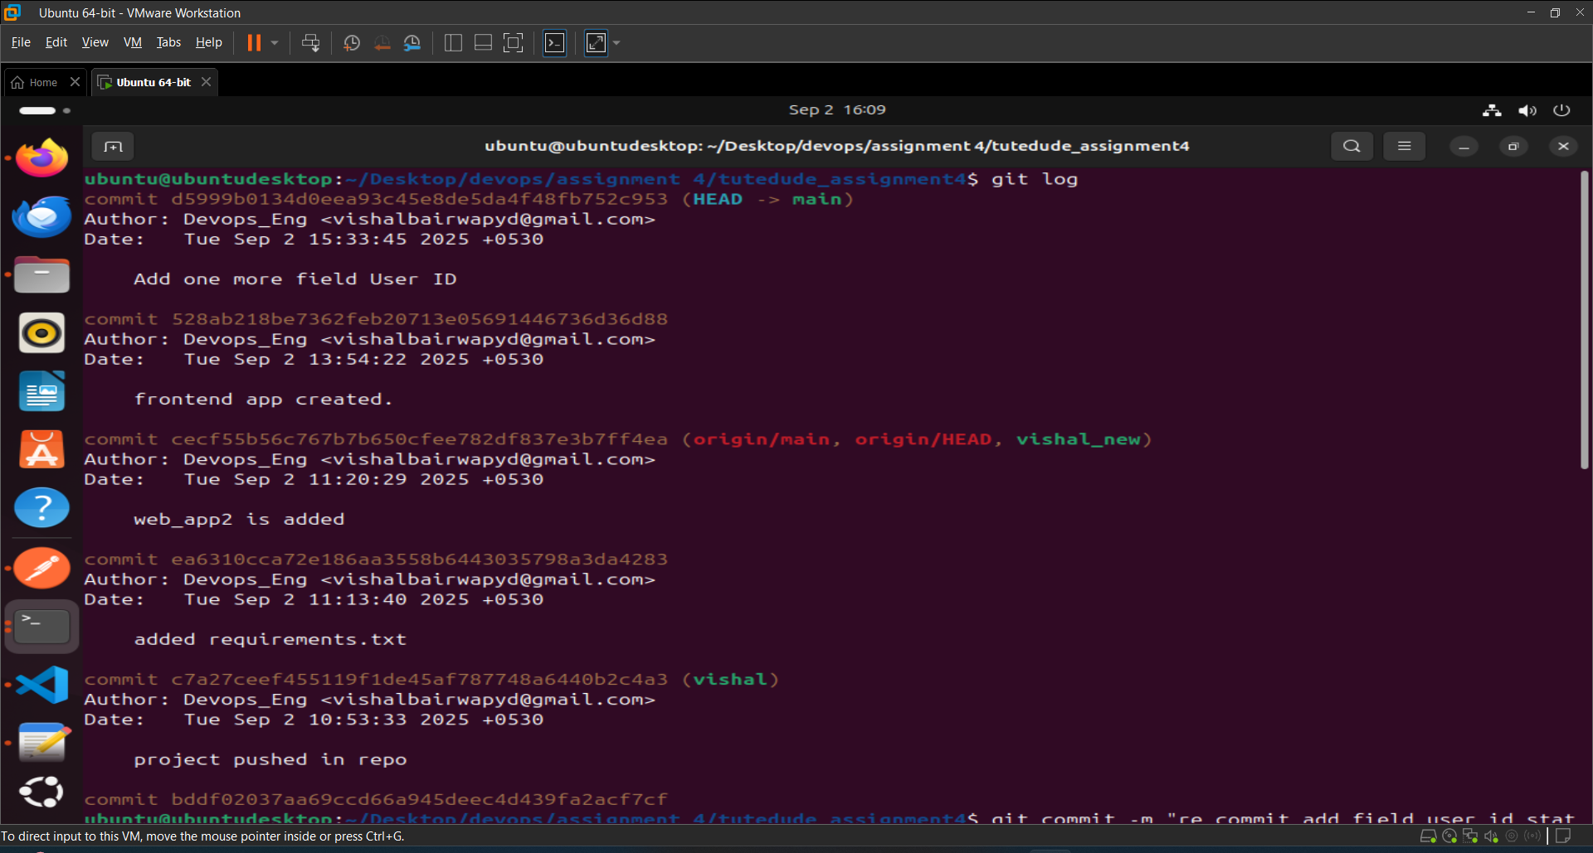

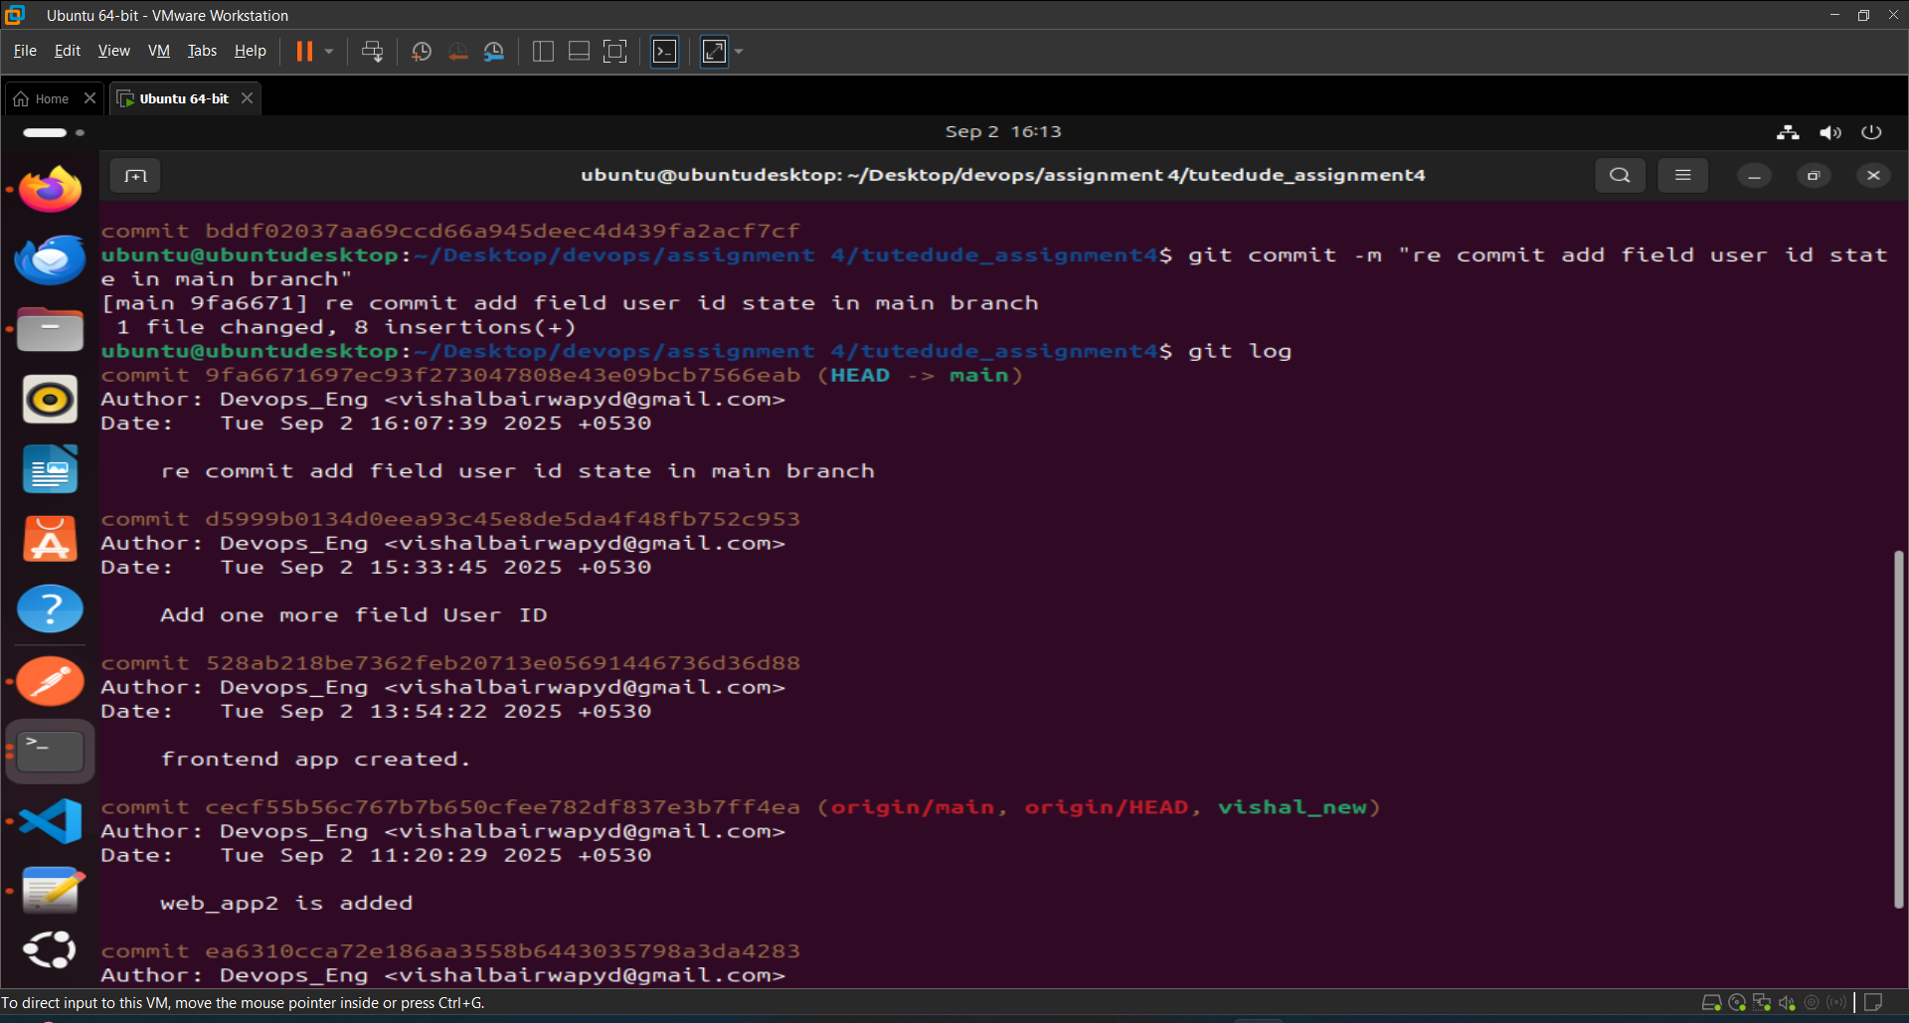

Step 7: Rebased the updated changes in the main branch to the master_1 branch by resolving some conflicts.

